M500 USE Manual
Trademarks
HUMZOR®, NEXZDAS®, NEXZLINK®, and NEXZSCAN® are trademarks of Shenzhen Hanzhi Technology Co., Ltd., registered in China, the United States and other countries. All other marks are trademarks or registered trademarks of their respective holders.
Copyright Information
No part of this manual may be reproduced, stored in a retrieval system or transmitted, in any form or by any means, electronic, mechanical, photocopying, recording, or otherwise without the prior written permission of HUMZOR.
Disclaimer of Warranties and Limitation of Liabilities
All information, specifications and illustrations in this manual are based on the latest information available at the time of printing.
HUMZOR reserves the right to make changes at any time without notice. While information of this manual has been carefully checked for accuracy, no guarantee is given for the completeness and correctness of the contents, including but not limited to the product specifications, functions, and illustrations.
HUMZOR will not be liable for any direct, special, incidental, indirect damages or any economic consequential damages (including lost profits).
IMPORTANT
Before operating or maintaining this unit, please read this manual carefully, paying extra attention to the safety warnings and precautions.
For Services and Support

www.humzor.com
www.humzor.cn


service@humzor.com
info@humzor.com
For details, please refer to the Service Procedures in this manual.
Safety Information
For your own safety and the safety of others, and to prevent damage to the device and vehicles upon which it is used, it is important that the safety instructions presented throughout this manual be read and understood by all persons operating or coming into contact with the device.
There are various procedures, techniques, tools, and parts for servicing vehicles, as well as in the skill of the person doing the work. Because of the vast number of test applications and variations in the products that can be tested with this equipment, we cannot possibly anticipate or provide advice or safety messages to cover every circumstance. It is the automotive technician's responsibility to be knowledgeable of the system being tested. It is crucial to use proper service methods and test procedures. It is essential to perform tests in an appropriate and acceptable manner that does not endanger your safety, the safety of others in the work area, the device being used, or the vehicle being tested.
Before using the device, always refer to and follow the safety messages and applicable test procedures provided by the manufacturer of the vehicle or equipment being tested. Use the device only as described in this manual. Read, understand, and follow all safety messages and instructions in this manual.
Safety Messages
Safety messages are provided to help prevent personal injury and equipment damage. All safety messages are introduced by a signal word indicating the hazard level.
DANGER
Indicates an imminently hazardous situation which, if not avoided, will result in death or serious injury to the operator or to bystanders.
WARNING
Indicates a potentially hazardous situation which, if not avoided, could result in death or serious injury to the operator or to bystanders.
Safety Warnings
- Always perform automotive testing in a safe environment.
- Wear safety eye protection that meets ANSI standards.
- Keep clothing, hair, hands, tools, test equipment, etc. away from all moving or hot engine parts.
- Operate the vehicle in a well-ventilated work area, for exhaust gases are poisonous.
- Put the transmission in PARK (for automatic transmission) or NEUTRAL (for manual transmission) and make sure the parking brake is engaged.
- Put blocks in front of the drive wheels and never leave the vehicle unattended while testing.
- Be extra cautious when working around the ignition coil, distributor cap, ignition wires and spark plugs. These components create hazardous voltages when the engine is running.
- Keep a fire extinguisher suitable for gasoline, chemical, and electrical fires nearby.
- Do not connect or disconnect any test equipment while the ignition is on or the engine is running.
- Keep the test equipment dry, clean, free from oil, water or grease. Use a mild detergent on a clean cloth to clean the outside of the equipment as necessary.
- Do not drive the vehicle and operate the test equipment at the same time. Any distraction may cause an accident.
- Refer to the service manual for the vehicle being serviced and adhere to all diagnostic procedures and precautions. Failure to do so may result in personal injury or damage to the test equipment.
- To avoid damaging the test equipment or generating false data, make sure the vehicle battery is fully charged and the connection to the vehicle DLC is clean and secure.
- Do not place the test equipment on the distributor of the vehicle. Strong electro-magnetic interference can damage the equipment.
CONTENTS
1.Using This Manual 4
1.1 Conventions 4
1.1.1 Bold Text 4
1.1.2 Notes and Important Messages 4
1.1.3 Illustrations 4
1.1.4 Procedures 4
2.General Introduction 4
2.1 Tablet 5
2.1.1 Functional Description 5
2.1.2 Technical Specifications 6
2.1.3 Technical Specifications 6
2.2 VCCI – Vehicle Communication and Check Interface 7
2.2.1 Functional Description 7
2.3 Software Overview 7
2.3.1 Overview 7
2.3.2 Features 7
2.3.3 VCI Connection 8
3.Diagnostic 8
3.1 Protocol Supported 8
3.2 Getting Started 9
3.3 Vehicle Menu Layout 9
3.4 Vehicle Identification 10
3.5 Vehicle Manual Select 11
4.Vehicle Test 11
4.1 Control Unit 13
4.2 ECU Information 13
4.3 Trouble Code 14
4.3.1 Read Code 15
4.4 Read Data Stream 17
4.5 Active Test 17
5.Special Function 18
6 Me 21
6.1 Unit 21
6.2 Upgrade 21
6.3 Settings 21
7.Search Engine 22
7.1 Run Mode 22
7.2 Language 22
7.3 Navigation Bar 22
7.4 Reset connection VCI 23
7.5 Screenshot 23

Using This Manual
This manual contains device usage instructions.
Some illustrations shown in this manual may contain modules and optional equipment that are not included in your system.

1.1 Conventions
The following conventions are used.

1.1.1 Bold Text
Bold text is used to highlight selectable items such as buttons and menu options.
Example:
Tap NEXT.

1.1.2 Notes and Important Messages
A NOTE provides helpful information such as additional explanations, tips, and comments.
The IMPORTANT indicates a situation that if not avoided may result in damage to the tablet or vehicle.

1.1.3 Illustrations
Illustrations used in this manual are samples, and the actual testing screen may vary for each vehicle being tested. Observe the menu titles and on-screen instructions to make correct option selection.

1.1.4 Procedures
An arrow icon indicates a procedure.
Example:
To use the Feedback:
1. Tap the Special button. The customers can use the functions they need to diagnose the vehicles.
2. Select the vehicle brand and type.
3. Tap the NEXT to select automatic scan or manual scan.

General Introduction
The M500 is a multi-platform diagnostic solution comprised of a powerful 10.1/9.6 inch TFT-LCD touchscreen Android-based tablet, a NEXZBOX communication and diagnostic measurement unit and an on-tool and cloud-based repair instructions and expert advice. As an intelligent diagnostic and information system, M500 not only displays the relevant repairs gathered from experienced industry experts, but provides step-by-step guidance to ensure the repair is done correctly and efficiently.
There are two main components to the M500 system:
M500 Tablet – the central processor and monitor for the system.
M500 VCI - Vehicle Communication and Check Interface.
This manual describes the construction and operation of these devices and how they work together to deliver diagnostic solutions.

2.1 Tablet

2.1.1 Functional Description
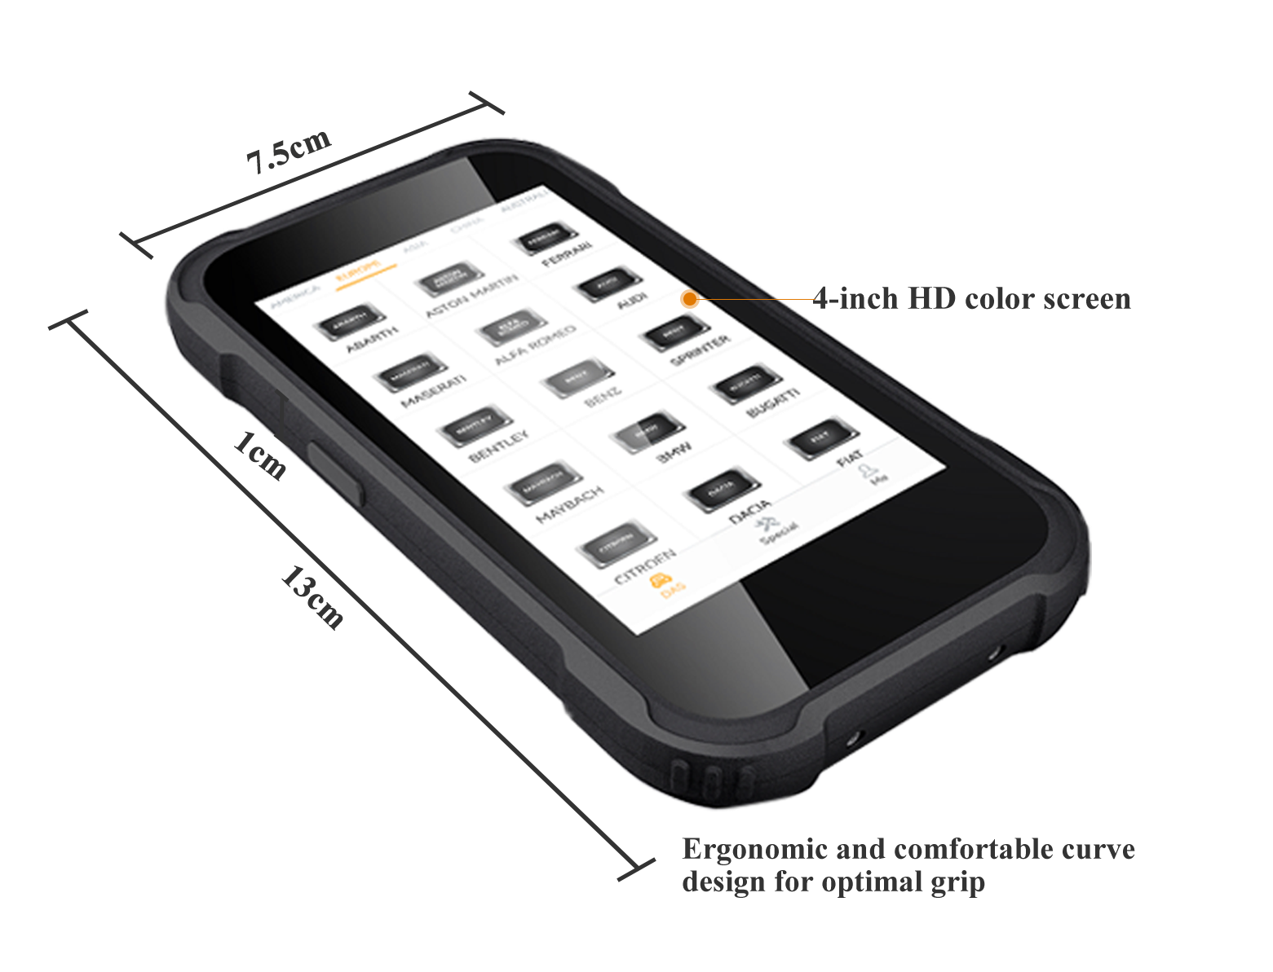
Figure 2-1 M500 Table Front View
1. 4.0 inch LCD Capacitive Touchscreen
2.Type-C charging port
3.Volume button for up and down
4.Reset button for restart tablet
5.Power button

2.1.2Power Source
The tablet can receive power from any of the following sources:
Internal Battery Pack
AC/DC Power Supply
IMPORTANT
Do not charge the battery when the temperature is lower than 0°C (32°F) or higher than 45°C (113°F).

Internal Battery Pack
The tablet can be powered with the internal rechargeable battery, which if fully charged can provide sufficient power for about 8 hours of continuous operation.
AC/DC Power Supply – using power adapter
The tablet can be powered from an electrical outlet using the AC/DC power adapter. The AC/DC power supply also charges the internal battery pack.

2.1.3 Technical Specifications
Name | Specifications
LCD | LCD：4.0 inch WVGA(480*800)
Frequency | GSM、WCDMA、LTE：Not required
T card | Support single T card，Support up to 32GB
Flash size | EMCP 8GB+1GB LP DDR3 or EMCP 4GB+512M LP DDR3
Wi-Fi | MPEG4-SP, H.264/AVC,H.263,3GP,3G2,MP4,MKV,AVI,1080P
GPS | Supported
G-Sensor | G-Sensor：supported
USB | 1 TYP-C connector，Support data transfer, charging, downloading and other functions
Charge | Support 5V 2A fast charger
Battery | About 2000mAh，Support high voltage battery 4.2V

2.2 VCCI – Vehicle Communication and Check Interface
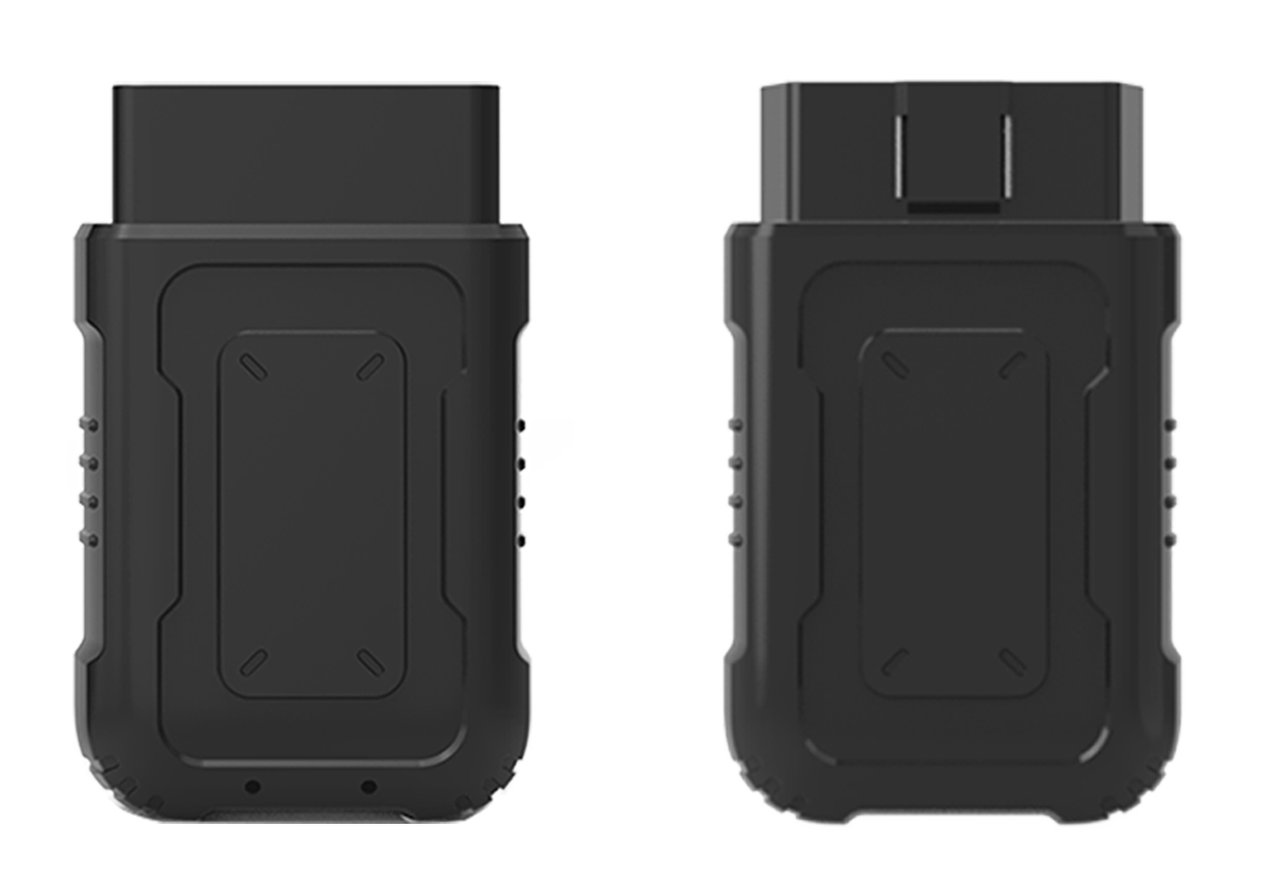
Figure 2-4 HUMZOR VCCI Top View

2.3 Software Overview

2.3.1 Overview
M500 is a tool-based APP which focus on car diagnosis, reset, key programming and other maintenance functions. It is connected to the vehicle through a specific Bluetooth (V5.0) device. The car owner or maintenance worker can learn the basic information and the existed faults of the vehicle in real time through the APP, etc., making vehicle maintenance become more convenient.

2.3.2 Features
① Wide coverage of vehicle brands of America, Europe, Asia, etc.
② Support full-system electronic control diagnosis, quickly scan the conditions of all electronic control systems of the car, and then generate professional diagnosis reports.
③ Special customization, special functions are supported, such as Oil reset, TPMS, DPF, etc.
④ Support reset connection VCI, one-click screenshot.
The software is easy to operate and reliable, guarantees the authenticity and security of information.

2.3.3 VCI Connection
You can connect the VCI device with M500 through the following steps:
- Insert the VCI tightly into the OBD port.
- Then the M500 will automatically scan and recognize the VCI device. At this time, the VCI icon on the top right turns blue, which means the VCI is successfully connected. If the VCI icon still shows red, it means the connection is not successful.

3. If the M500 cannot automatically connect to your VCI device, or the device fails to connect, please manually click the VCI icon on the top right to reconnect, or check whether the VCI is well connected to the car's OBD port.

Diagnostic
1. Support Truck brands: American, European, Asian.
2. Support more than 100 special functions, external 9 kinds of common special functions.

3.1 Protocol Supported
High Speed CAN - offers baud rates from 40 Kbit/s to 1 Mbit/sec, depending on cable length. This is the most popular standard for the physical layer, since it allows for simple cable connection between devices. High speed CAN networks are terminated with 120 ohm resistors on each end of the networ
Low Speed CAN - offers baud rates from 40 Kbit/s to 125 Kbits/sec. This standard allows CAN bus communication to continue in case of a wiring failure on the CAN bus lines. In low speed CAN networks, each device has its own termination.
J1939 CAN - is used in the commercial vehicle area for communication throughout the vehicle with the physical layer defined in ISO 11898. Under J1939/11 and J1939/15, the data rate is specified as 250 Kbit/s, with J1939/14 specifying 500 Kbit/s.
J1708 (SAE) - the standard defines a double-wire 18-gauge cable that can run upto 130 feet (40 m) and operates at 9600 bit/s

3.2 Getting Started
Prior to first use of the diagnostics application, ensure the VCI device is properly connected to and is communicating with the tablet.

3.3 Vehicle Menu Layout
For example:
Click on DAS->ASIA
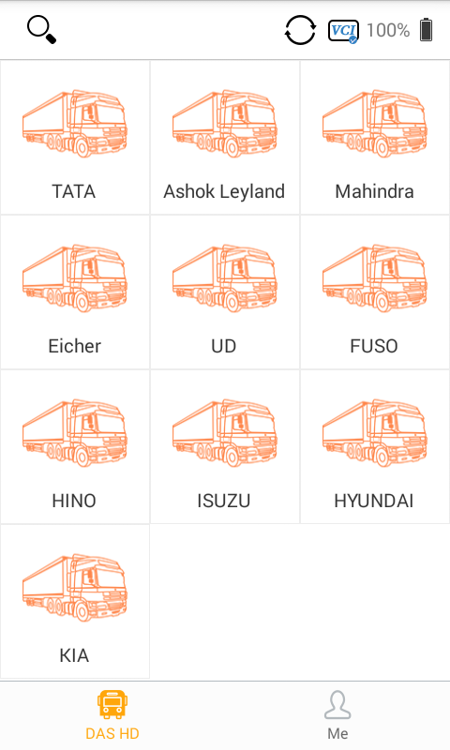

Manufacturer Buttons
The Manufacturer buttons display the various vehicle brand names. Select the manufacturer button after the VCI device is properly connected to the test vehicle to start diagnostic session.
Select ASIA->ISUZU brand to check.

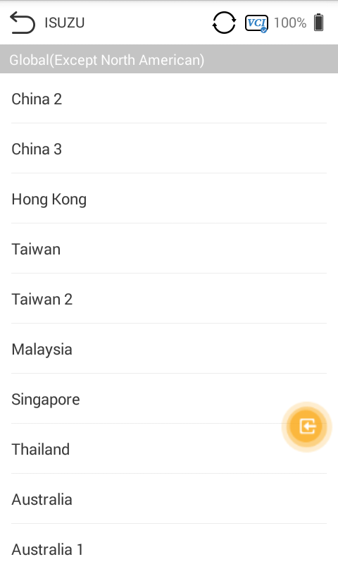

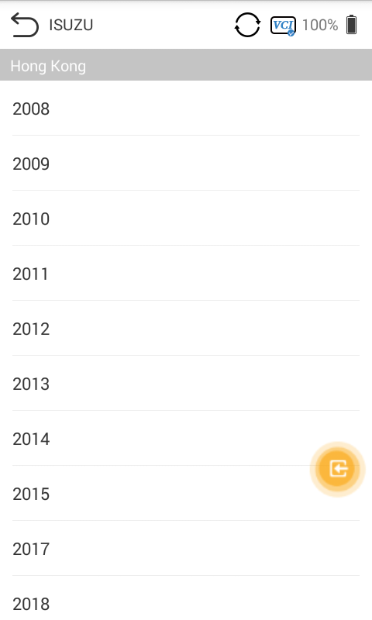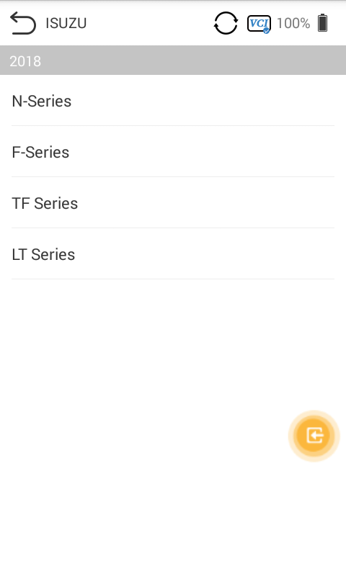

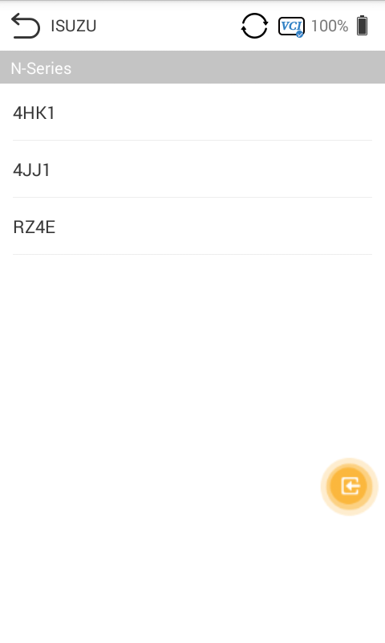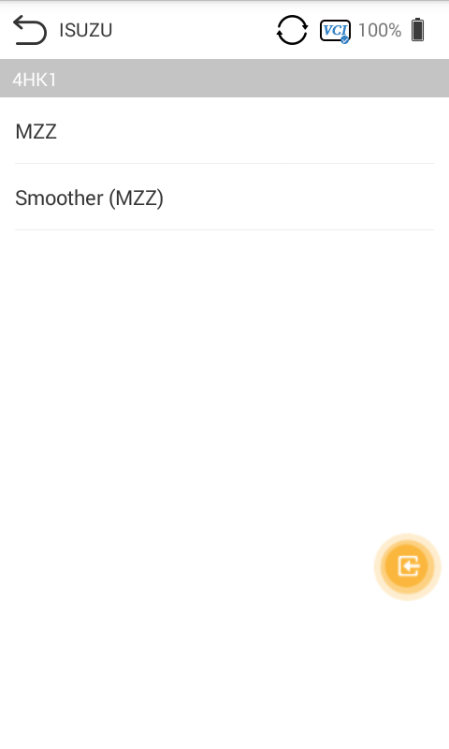

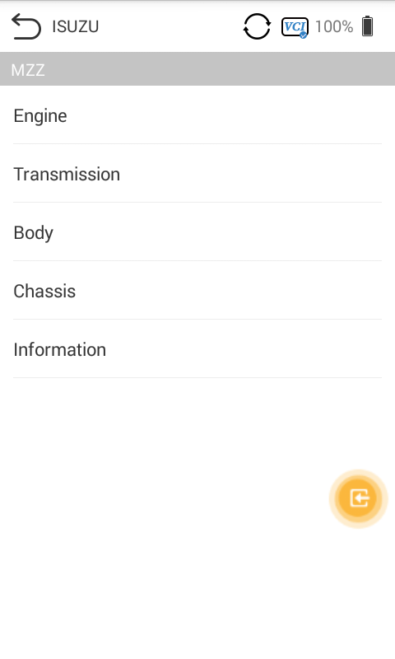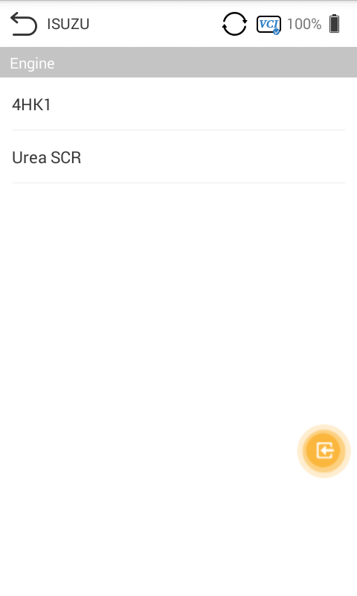

Vehicle System Test

4.1 Control Unit
This option allows you to manually locate a required control system for testing through a series of choices. Simply follow the menu driven proce¬dure, and make proper selection each time; the program will guide you to the diagnostic function menu after a few choices you've made.

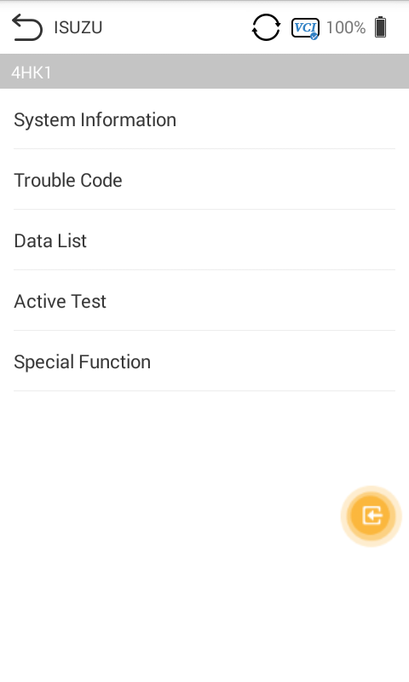

Available functions may vary by vehicle. The function menu may include:
System information - displays detailed ECU information. Select to display information screen.
Trouble codes - contains Read Codes and Erase Codes. The former displays detailed DTC information retrieved from the vehicle control module, the latter facilitates you to erase DTCs and other data from the ECU.
•Live data - retrieves and displays live data and parameters from the vehicle's ECU.
•Active test - provides specific subsystem and component tests. This selec¬tion may display as Actuators, Actuator Test, or Function Tests. Available tests vary by vehicle.
•Special functions - provides component adaptation or variant coding functions for custom configurations, and allows entry of adaptive values for certain component after repairs. Depending on the test vehicle, this selection may sometimes appear.

4.2 ECU Information
This function retrieves and displays the specific information for the tested control unit, including unit type and version numbers.
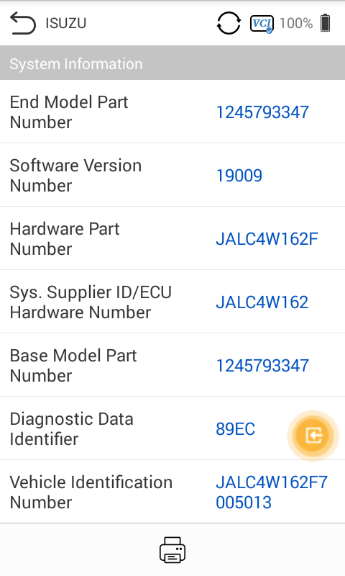

4.3 Trouble Code
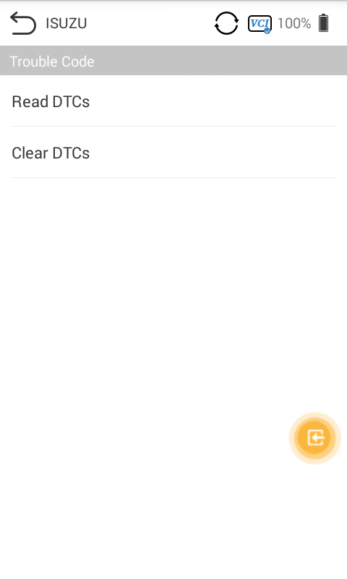

4.3.1 Read Code
This function retrieves and displays the DTCs from the vehicle control system. The Read Codes screen varies for each vehicle being tested. For some vehicles, freeze frame data can also be retrieved for viewing. A sample Read Codes screen displays as below:
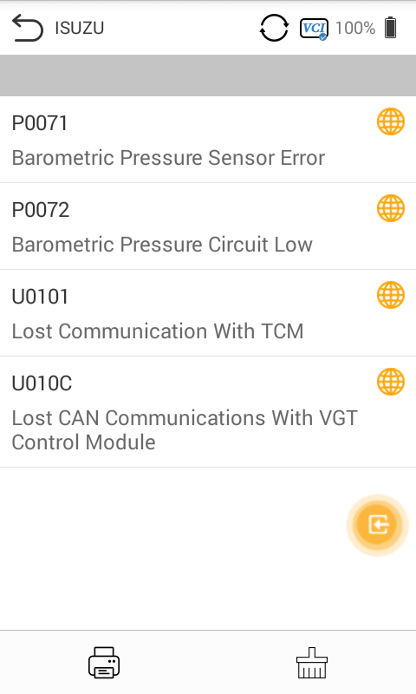

Search - tap to serach the selected DTC for additional information on the internet.
Clear DTCs - tap to erase codes from the ECU. It is recommended that DTCs are read and needed repairs are performed before erasing codes.
Read DTCs - retrieves and displays the DTCs from the vehicle control system. The Read Codes screen varies for each vehicle being tested.

4.3.2 Erase Codes
After reading the retrieved codes from the vehicle and certain repairs have been made, you can erase the codes from the vehicle using this function. Before performing this function, make sure the vehicle's ignition key is in the ON (RUN) position with the engine off.
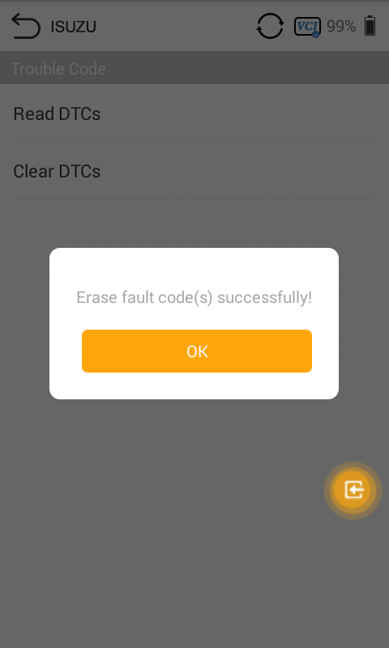
- To perform Manual Input
- Tap Clear Codes in the Function Menu.
- A warning message displays to inform you of data loss when this function is applied.
- Tap YES to continue. A confirming screen displays when the operation is successfully done.
- Tap NO to exit.
- Tap ESC on the confirming screen to exit Erase Codes.
Check the Read Codes function again to ensure the operation is successful.

4.4 Read Data Stream
When this function is selected, the screen displays the data list for the selected module. The parameters display in the order that they are transmitted by the ECU, so expect variation amongvehicles.
Gesture scrolling allows you to quickly move through the data list. Touch the screen and drag your finger up or down to reposition the parameters being displayed if the data occupies more than one screen. The figure below displays a typical Live Data screen:
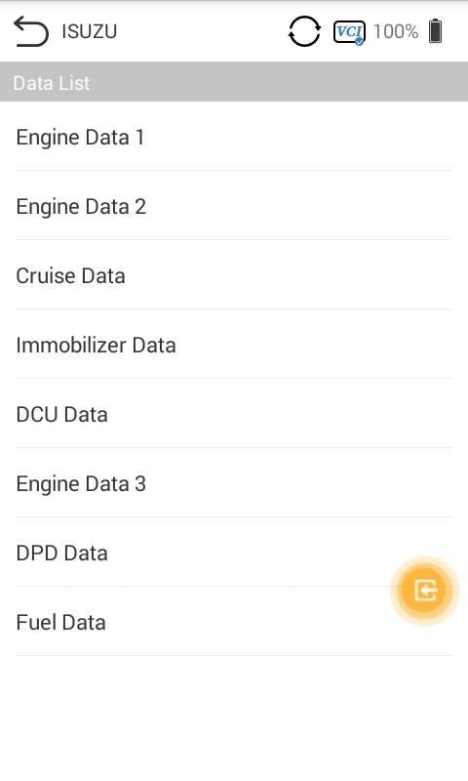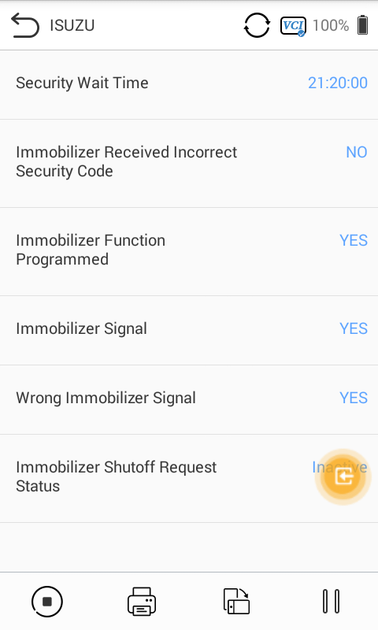

4.5 Active Test
The Active Test function is used to access vehicle-specific subsystem and component tests. Available tests vary by vehicle.
During an active test, the tablet sends commands to the ECU to activate the actuators. This test determines the integrity of the system or part by reading ECU data, or by monitoring the operation of the actuators. Such tests may include switching a solenoid, relay, or switch, between two operating states.
Selecting Active Test displays a menu of test options. Available tests vary by vehicle. Select test from menu option. Follow the instructions displayed on screen to complete test. Procedures and instructions vary by vehicle.

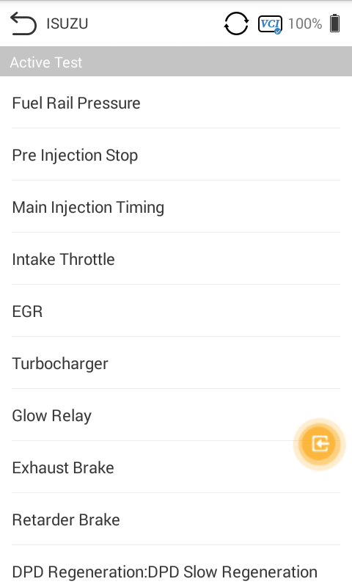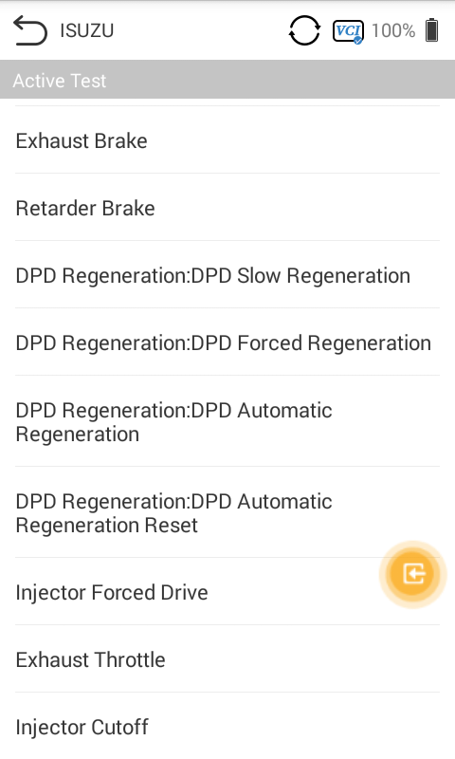

The functional buttons in the lower right corner of the Active Test screen manipulate the test signals. The operational instructions are displayed in the main section of the test screen. Follow the on-screen instructions and make appropriate selections to complete the tests.
Tap the ESC functional button to exit the test when finished.

5.Special Function
These functions perform various component adaptations, including the recalibrate or configuration of certain components after repairs or replacements have been completed.
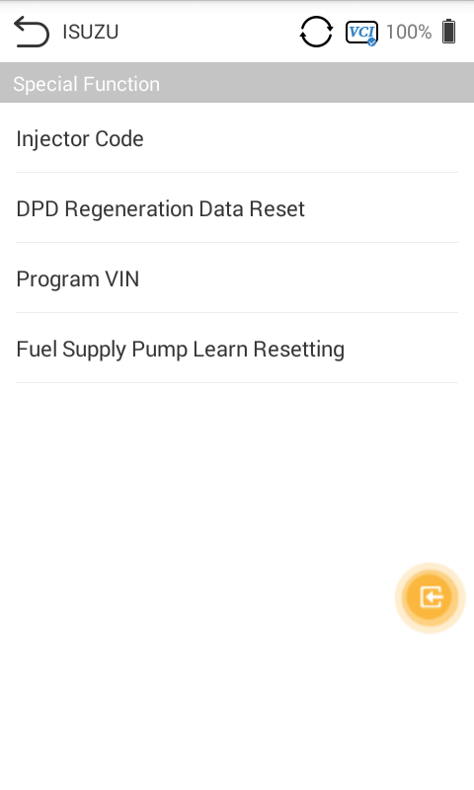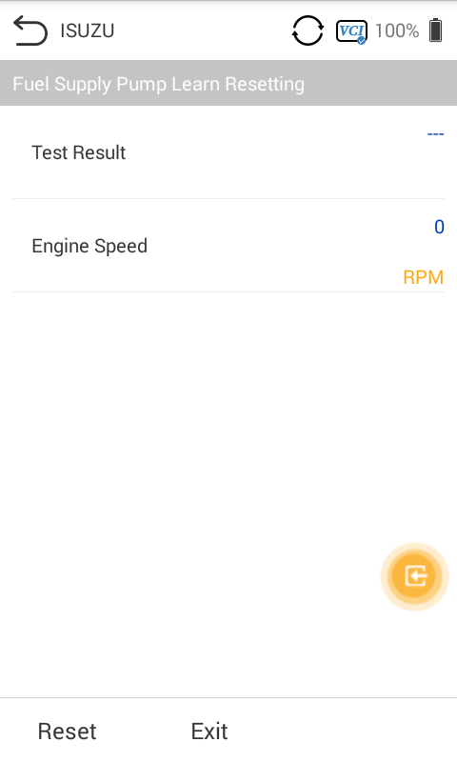

6 Me
On the "HUMZOR" main interface, click the "Me" icon button, and the system will guide you to the interface.

6.1 Unit
In the Settings interface, click the "Units" button to switch the units.

6.2 Upgrade
If your M500 application is not the latest version, you can upgrade the application version through the following steps:
- On the Me interface, click the "Upgrade" icon button.
- Click the "Download" button on the right to start downloading the new version.
- The version is downloaded successfully, click the "INSTALL" button to start the installation.
- The version is downloaded successfully, click the "INSTALL" button to start the installation.

6.3 Settings
Click System Info and you can view the information of the application.
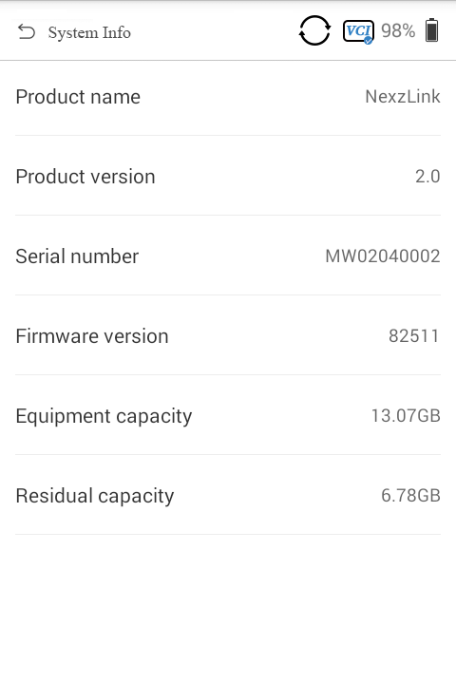

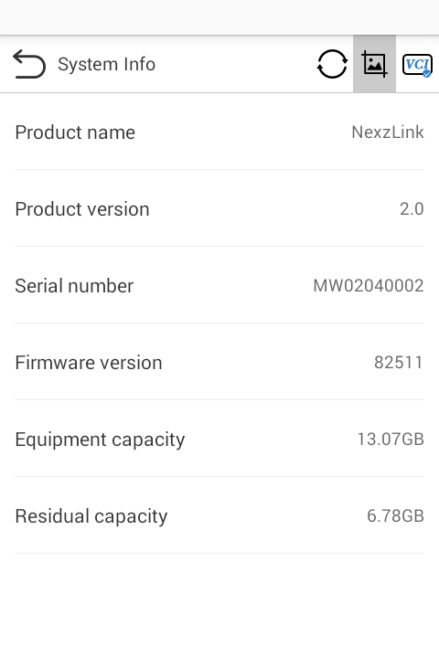

7.Search Engine
In the Settings interface, click the "Search Engine" button to switch the Engine Google or Baidu.

7.1 Run Mode
In the Settings interface, click the "Run Mode" button to switch between modes.

7.2 Language
You can switch the display language through the following steps:
- On the Settings interface, click Language, the system will guide you to the language selection interface.
- Click the language you need to display, the language switch setting completes.

7.3 Navigation Bar
The buttons on the navigation bar from left to right are Reset connection VCI, Screenshots, Bluetooth connection.

7.4 Reset connection VCI
Open the home page of the app, click the first icon on the top right. Click OK to reset connection VCI. Then please wait for the initialization of VCI. After that, the VCI will be successfully reset.

7.5 Screenshot
When you use the M500 application, you can save a screenshot of the current interface through the following steps:
On the main interface, click the 图 icon on the right side of the top navigation bar, the screenshot is saved successful, and you can view it on the "Gallery" interface.

