NEXZCHECK NC601

Car and Truck OBD2 Scan Tool
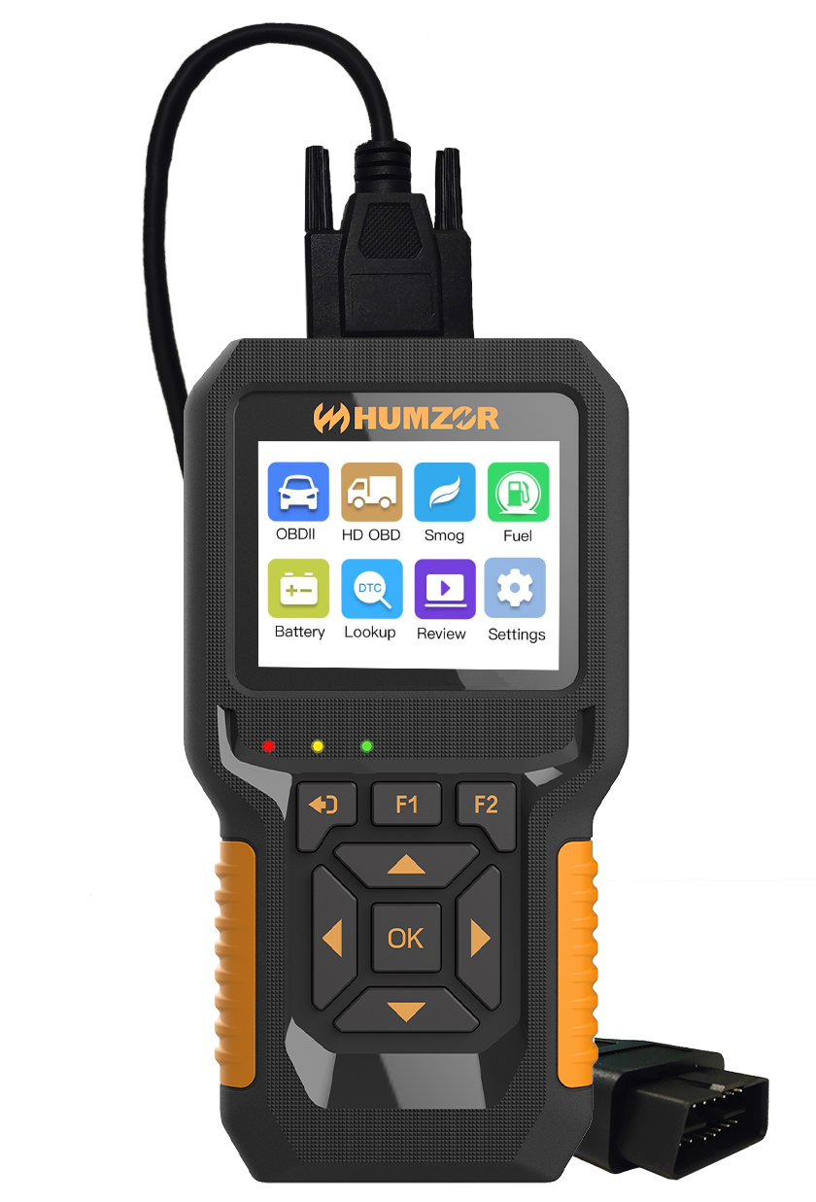

User's Manual
Trademarks
HUMZOR®, NEXZSYS®, NEXZLINK®, NEXZSCAN®, and NEXZSYS® are trademarks of Shenzhen Hanzhi Technology Co., Ltd., registered in China, the United States and other countries. All other marks are trademarks or registered trademarks of their respective holders.
Copyright Information
No part of this manual may be reproduced, stored in a retrieval system or transmitted, in any form or by any means, electronic, mechanical, photocopying, recording, or otherwise without the prior written permission of HUMZOR.
Disclaimer of Warranties and Limitation of Liabilities
All information, specifications and illustrations in this manual are based on the latest information available at the time of printing.
HUMZOR reserves the right to make changes at any time without notice. While information of this manual has been carefully checked for accuracy, no guarantee is given for the completeness and correctness of the contents, including but not limited to the product specifications, functions, and illustrations.
HUMZOR will not be liable for any direct, special, incidental, indirect damages or any economic consequential damages (including lost profits).
IMPORTANT
Before operating or maintaining this unit, please read this manual carefully, paying extra attention to the safety warnings and precautions.
For Services and Support

www.humzor.com
www.humzor.cn
service@humzor.com
info@humzor.com
For details, please refer to the Service Procedures in this manual.
Safety Information
For your own safety and the safety of others, and to prevent damage to the device and vehicles upon which it is used, it is important that the safety instructions presented throughout this manual be read and understood by all persons operating or coming into contact with the device.
There are various procedures, techniques, tools, and parts for servicing vehicles, as well as in the skill of the person doing the work. Because of the vast number of test applications and variations in the products that can be tested with this equipment, we cannot possibly anticipate or provide advice or safety messages to cover every circumstance. It is the automotive technician's responsibility to be knowledgeable of the system being tested. It is crucial to use proper service methods and test procedures. It is essential to perform tests in an appropriate and acceptable manner that does not endanger your safety, the safety of others in the work area, the device being used, or the vehicle being tested.
Before using the device, always refer to and follow the safety messages and applicable test procedures provided by the manufacturer of the vehicle or equipment being tested. Use the device only as described in this manual. Read, understand, and follow all safety messages and instructions in this manual.
Safety Messages
Safety messages are provided to help prevent personal injury and equipment damage. All safety messages are introduced by a signal word indicating the hazard level.

DANGER
Indicates an imminently hazardous situation which, if not avoided, will result in death or serious injury to the operator or to bystanders.
WARNING
Indicates a potentially hazardous situation which, if not avoided, could result in death or serious injury to the operator or to bystanders.
Safety Warning
- Always perform automotive testing in a safe environment.
- Wear safety eye protection that meets ANSI standards.
- Keep clothing, hair, hands, tools, test equipment, etc. away from all moving or hot engine parts.
- Operate the vehicle in a well-ventilated work area, for exhaust gases are poisonous.
- Put the transmission in PARK (for automatic transmission) or NEUTRAL (for manual transmission) and make sure the parking brake is engaged.
- Put blocks in front of the drive wheels and never leave the vehicle unattended while testing.
- Be extra cautious when working around the ignition coil, distributor cap, ignition wires and spark plugs. These components create hazardous voltages when the engine is running.
- Keep a fire extinguisher suitable for gasoline, chemical, and electrical fires nearby.

- Do not connect or disconnect any test equipment while the ignition is on or the engine is running.
- Keep the test equipment dry, clean, free from oil, water or grease. Use a mild detergent on a clean cloth to clean the outside of the equipment as necessary.
- Do not drive the vehicle and operate the test equipment at the same time. Any distraction may cause an accident.
- Refer to the service manual for the vehicle being serviced and adhere to all diagnostic procedures and precautions. Failure to do so may result in personal injury or damage to the test equipment.
- To avoid damaging the test equipment or generating false data, make sure the vehicle battery is fully charged and the connection to the vehicle DLC is clean and secure.
- Do not place the test equipment on the distributor of the vehicle. Strong electromagnetic interference can damage the equipment.

CONTENTS
1. Product Instructions 6
1.1 Product Description 6
1.2 Specifications 7
1.3 Accessories Included 7
1.4 Keyboard 7
1.5 Power 7
2. OBD (On-Board Diagnostics) II Introduction 8
2.1 On-Board Diagnostics(OBD)II 8
2.2 Data Link Connector (DLC) 8
3. OBD-II Diagnosis 8
3.1 Read DTCs (Diagnostic Trouble Codes) 9
3.2 Clear DTCs 11
3.3 Live Data 12
3.4 Freeze Frame Data 13
3.5 I/M Readiness Monitors 14
3.6 MIL Status 15
3.7 Vehicle Information 15
3.8 Mode 6 16
3.9 Mode 8 16
3.10 Smog Check 17
3.11 Fuel Analysis 17
4. HD OBD Diagnosis 17
4.1 Read DTCs 17
4.2 Clear DTCs 18
4.3 Live Data 19
4.4 Vehicle Information 19
5. Battery Test 20
6. Look up 20
7. Review 20
7.1 Review DTC 21
7.2 Printing Data 21
8. Setting 21
8.1 Language Setup 22
8.2 Help Function 22
8.3 Unit of Measure 22
8.4 Beep Setting 22
8.5 Device Self-Test 23
8.5.1 Screen Test 23
8.5.2 LCD Test 23
8.5.3 Key Test 23
8.6 Vehicle Coverage 24
8.7 Protocol Coverage 25
8.8 Test Mode Coverage 25
8.9 Product Trouble shooting 26
9. Update and Warranty 27
9.1 Software Update 27
9.2 Limited Three Year Warranty 27
9.3 Service Procedures 27

1. Product Instructions

1.1 Product Description
NC601 is easy to carry, simple to operate, fast in diagnosis, large in memory, comprehensive in code base, powerful in performance and novel in design. It is a new generation OBDII diagnostic tool tailored for the owner. Data Live, Freeze Frame, Read DTC, Clear DTC, O2 Sensor Test, On-board Test (Mode 6), Smog Check, I/M Readiness, EVAP Test (Mode 8), Vehicle Info, MIL Status, Battery Test, Fuel Analysis, Performance Data, Engine Data, DTC Query, Data Review, Printer, Settings are fully covered.
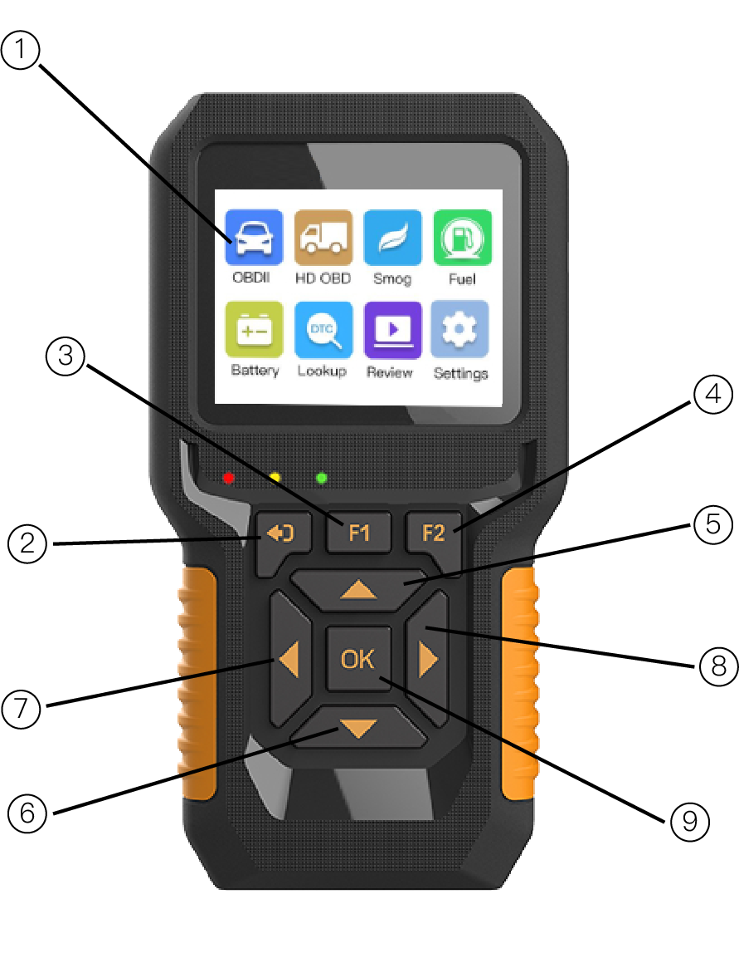
Figure 1-1 Product Display
1. LCD Screen: Indicates test results.
2. ESC Button: Returns to the previous screen. Checks Data stream after selecting specific data items.
3. F1 Button: F1 is the help function in the main screen, and the back to the main screen in the diagnostic screen
4. F2 Button: One-key I/M Readiness operations.
5. Up Button: Moves up through menu and sub-menus. Moves to previous screen if information covers more than one screen.
6. Down Button: Moves down through menu and sub-menus. Moves to next screen if information covers more than one screen.
7. Left Button: Moves to previous screen if information covers more than one screen.
8. Right Button: Moves to next screen if information covers more than one screen.
9. OK Button: Conforms a selection from a menu.

1.2 Specifications
Table 1-1 Hardware Information
Display Screen | TFT Color (320*240)
Operating Temperature | 0 to 60℃ (32 to 140℉)
Storage Temperature | -20 to 70℃ (-4to 158℉)
Power | 12V / 24V (power provided by vehicle battery)

1.3 Accessories Included
1. User's Manual-- Instructions on tool operations.
2. OBDII cable (DLC) -- Data Link Connector or Diagnostic Link Connector, provides power to tool and communication between tool and vehicle.
3. USB cable -- Used to print retrieved data and update software.
4. Protective ABS Case--A ABS case to store the tool when not in use.

1.4 Keyboard
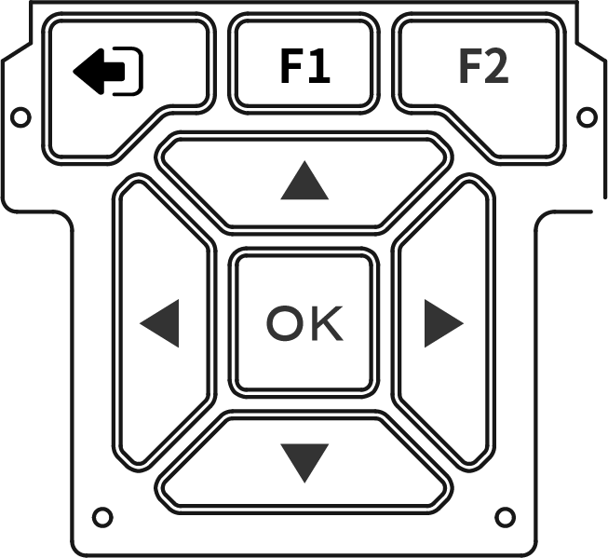

Figure 1-2 Keyboard Display

1.5 Power
The scan tool is powered via the vehicle Data Link Connector (DLC). Just follow the steps below to turn on the scan tool:
- Connect the OBD II Cable to scan tool.
- Find DLC on vehicle.
- Plug OBD II cable to the vehicle's DLC.
- Power up the scan tool, and wait for the Main Screen to appear.
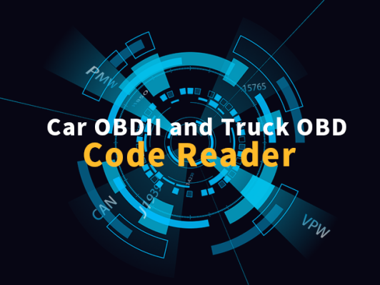
Figure 1-3 Main Screen Interface

2. OBD (On-Board Diagnostics) II Introduction

2.1 On-Board Diagnostics(OBD)II
The first generation of On-Board Diagnostics (called OBD I) was developed by the California Air Resources Board (ARB) and implemented in 1988 to monitor some of the emission control components on vehicles. As technology evolved and the desire to improve the On-Board Diagnostic system increased, a new generation of On-Board Diagnostic system was developed. This second generation of On-Board Diagnostic regulations is called "OBDII".
The OBD II system is designed to monitor emission control systems and key engine components by performing either continuous or periodic tests of specific components and vehicle conditions. When a problem is detected, the OBD II system turns on a warning lamp (MIL) on the vehicle instrument panel to alert the driver typically by the phrase of "Check Engine" or "Service Engine Soon". The system will also store important information about the detected malfunction so that a technician can accurately find and ﬁx the problem. Here below follow three pieces of such valuable information：
1. Whether the Malfunction Indicator Light (MIL)is commanded ‘on’ or ‘off’;
2. Which, if any, Diagnostic Trouble Codes (DTCs) are stored
3. Readiness Monitor status.

2.2 Data Link Connector (DLC)
The DLC (Data Link Connector or Diagnostic Link Connector) is the standardized 16-cavity connector where diagnostic scan tools Interface with the vehicle's on-board computer. The DLC is usually located 12 inches from the center of the instrument panel (dash), under or around the driver's side for most vehicles. If Data Link Connector is not located under dashboard. a label should be there telling location. For some Asian and European vehicles, the DLC is located behind the ashtray and the ashtray must be removed to access the connector. If the DLC cannot be found, refer to the vehicle's service manual for the location.
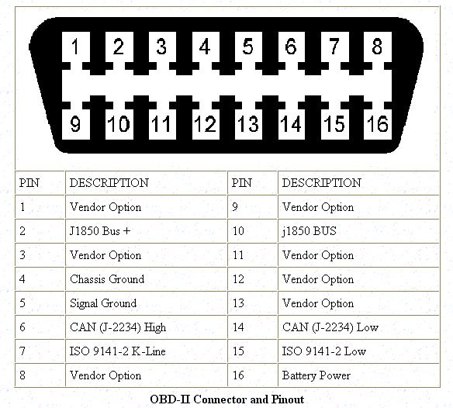

3. OBD-II Diagnosis
The OBD II Diagnostics function is a fast-access option that allows you to carry out a quick test on the engine system of OBD II. When more than one vehicle control module is detected by the scan tool, you will be prompted to select the module where the data may be retrieved. The most often to be selected are the Power-train Control or into the vehicle's DLC.
1. Turn the ignition on. Engine can be off or running.
2. Turn on the scan tool. Select OBDII from the Main Screen.
3. Press the OK button to wait for the Menu to appear. A sequence of messages displaying the OBDII protocols will be observed on the display until the vehicle protocol is detected.
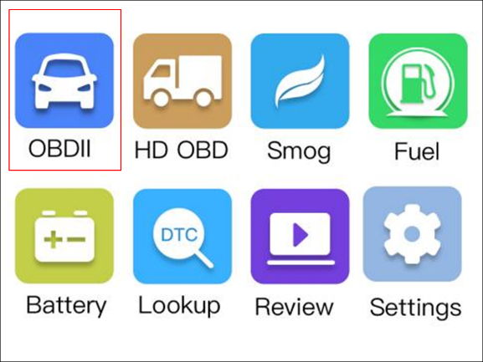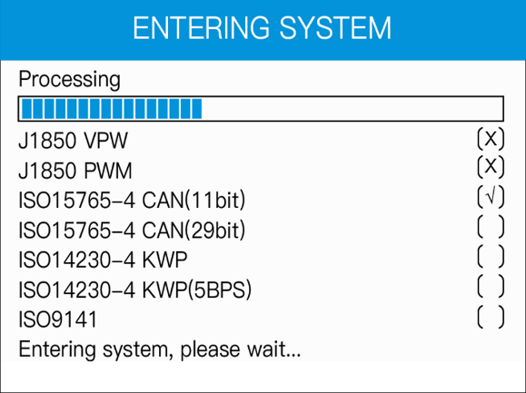
Figure 3-1-1 Main Interface Figure 3-1-2 Detection protocol Interface
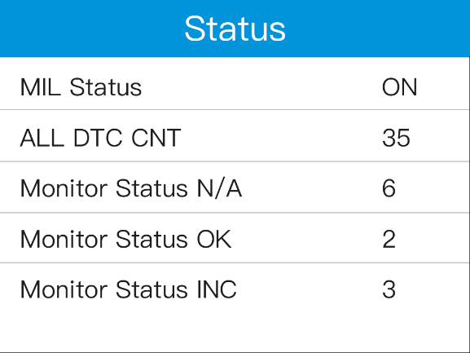
Figure 3-1-3 Vehicle System Status Interface

3.1 Read DTCs (Diagnostic Trouble Codes)
OBD II Diagnostic Trouble Codes are codes that are stored by the on-board computer diagnostic system in response to a problem found in the vehicle. These codes identify a particular problem area and are intended to provide you with a guide as to where a fault might be occurring within a vehicle.
There are three types of DTCs:
1. Stored DTCs - A DTC is stored when a fault condition has occurred that meets enough criteria to activate the MIL.
2. Pending DTCs - When a fault condition is identiﬁed during a Drive Cycle, but does not meet enough criteria to activate the MIL. If the fault condition occurs during two consecutive Drive Cycles, it will turn into a Stored DTC and the MIL will activate.
3. Permanent DTCs - A stored DTC that can only be cleared by the OBDII system, after repairs are made, and a set number of Driving Cycles have been completed.
OBD II Diagnostic Trouble Codes consists of a five-digit alphanumeric code. The first character, a letter, identifies which control system sets the code. The other four characters, all numbers, provide additional information on where the DTC originated and the operating conditions that caused it to set. Here below is an example to illustrate the structure of the digits:
DTC Example:
P 0 2 0 2

P--Systems: B=Body C= Chassis P=Powertrain U=Network
0--Code Type Generic(SAE): P0, P2, P34-P39; B0, B3; C0, C3;U0, U3 (Manufacturer Specific: P1, P30-P33; B1, B2; C1, C2; U1,U2)
2--Sub-systems:
1=Fuel and Air Metering
2=Fuel and Air Metering
3=Ignition System or Engine Misfire
4=Auxiliary Emission Controls
5=Vehicle Speed Control and Idle Controls
6=Computer Output Circuits
7=Transmission Controls
8=Transmission Controls

02--Identifying specific malfunction section of the systems
Read DTCs as follows:
1. Use UP/DOWN scroll button to select Read DTC from Diagnostic Menu and press OK button.
2. Use the UP/DOWN scroll button to select Stored DTCs, Pending DTCs, Permanent DTCs or Record DTC from the Read Codes menu and press the OK button.
Module [PCM] and Transmission Control Module [TCM]. The US regional models can read other modules, such as ABS, SRS etc., greatly support data reading of 8 modules at a time.

CAUTION: Don't connect or disconnect any test equipment with ignition on or engine running.
1. Turn the ignition off.
2. Locate the vehicle's 16-pin Data Link Connector (DLC).
3. Plug the scan tool cable connect
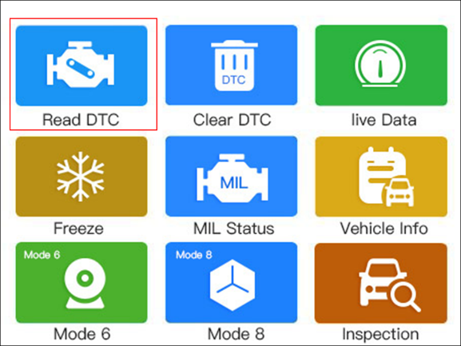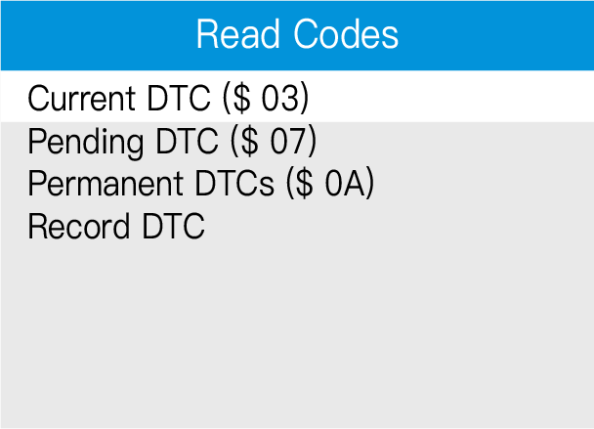
Figure 3-1-4 OBD2 Function Selection Interface Figure 3-1-5 Read Codes Interface

If there is not any Diagnostic Trouble Code, the display indicates “The vehicle has no fault codes!” Wait a few seconds or press any key to return to previous screen.
NOTE:
Permanent Codes function is available for merely vehicles supporting the CAN protocols.
1. View DTCs and their definitions on screen
2. If more than one DTC is found, use the UP/DOWN scroll button to check all the codes.
If retrieved DTCs contain any manufacturer specific or enhanced codes, a “The vehicle’s code is defined by the manufacturer, please enter to select the manufacturer.” message comes up prompting you to select vehicle manufacturer to view DTC definitions. Use UP/DOWN scroll button to select manufacturer and then press OK button to conﬁrm.
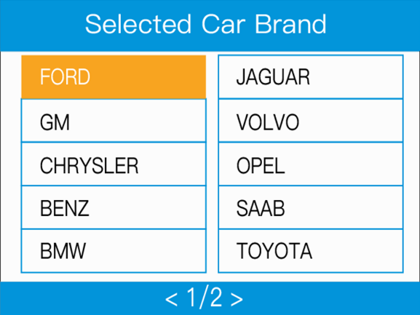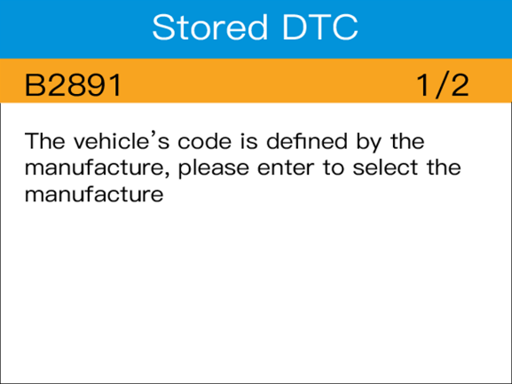
Figure 3-1-6 select Car Brand Selection Interface Figure 3-1-7 Stored DTC Interface
NC601 indicator status
1. Green light
A has no fault code or broken line
B has permanent code
2. Red light
A has stored code
B has current code and permanent code
3. Yellow light
A has pending code
B has pending code and permanent code
4. Red and yellow lights
A has stored code and pending code
B has current code, pending code and permanent code

3.2 Clear DTCs
CAUTION: Erasing the Diagnostic Trouble Codes may allow the scan tool to delete not only the codes from the vehicle's on-board computer, but also "Freeze Frame" data and manufacturer specific enhanced data. Further, the I/M Readiness Monitor Status for all vehicle monitors is reset to Not Ready or Not Complete status. Do not erase the codes before the system has been checked completely by a technician.
NOTE: Erasing codes does not mean that trouble codes in ECU have been eliminated completely. As long as there is fault with the vehicle, the trouble codes keep on presenting.
This function is performed with key on engine off (ROEO). Do not start the engine.
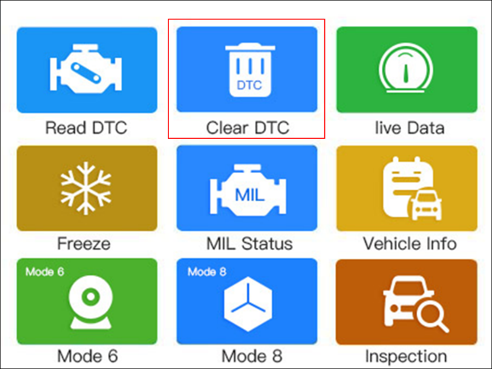
Figure 3-2-1 Clear DTC Selection Interface
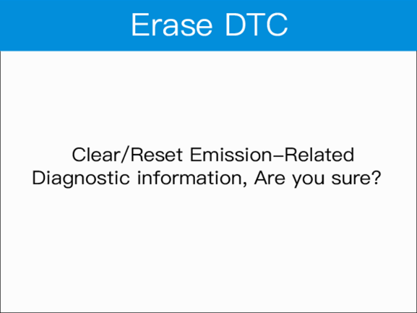 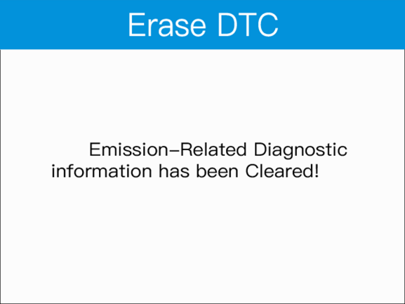Figure 3-2-2 Erase DTC Interface Figure 3-2-3 Erase Result Interface
1. Use the UP/DOWN scroll buttons to select Clear DTCs from Diagnostics Menu and press the OK button.
2. Choose whether to erase codes or not.

3.3 Live Data
In this function, you can not only read the live data but also record data for later review.
Viewing Data: allows viewing of live or real time PID data of vehicles computer module(s).
To view live data, use the UP/DOWN scroll button to select Live Data from Diagnostic Menu and press the OK button.
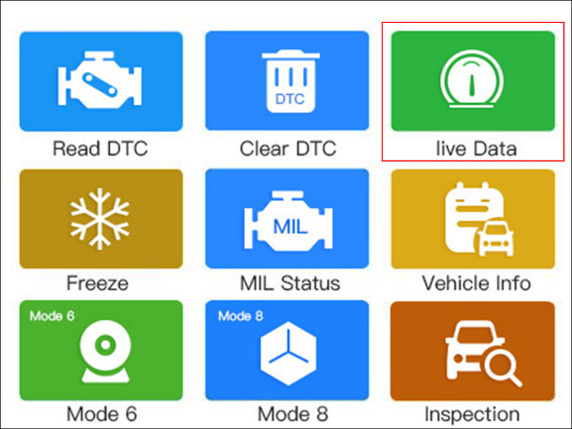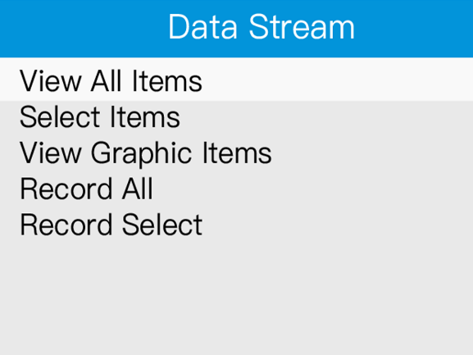
Figure 3-3-1 Data Stream Selection Interface Figure 3-3-2 Data Stream Interface
A. View All Items
1. To view complete set of data, use UP/DOWN scroll button to select View All Items from Live Data menu and press the OK button.
2. View live PIDs on the screen. Use the UP/DOWN or Left/Right scroll button for more PIDs if additional information is available on more than one page.
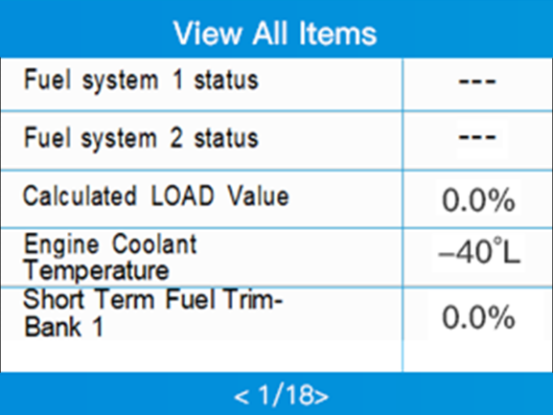
Figure 3-3-3 Items Interface
B. Select Items
To view customized PID data, click Select Items from Live Data menu and press the OK button.
1. Use the UP/DOWN scroll button to get the desired items and click OK button to conﬁrm.
2. Press ESC to view the selected PIDs.
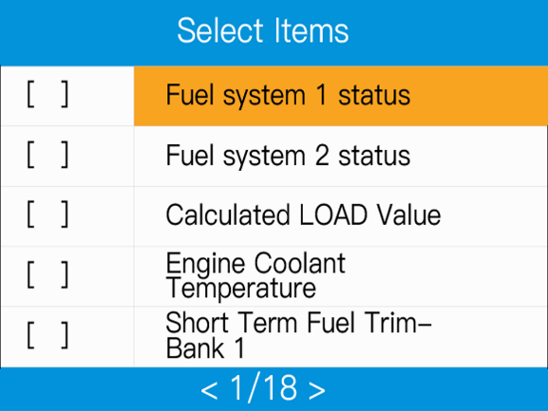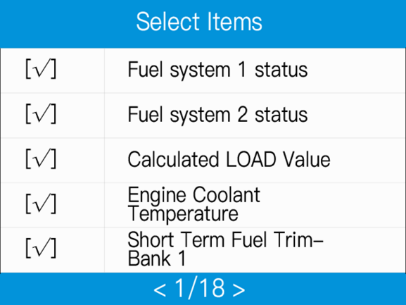
Figure 3-3-4 Items Selection Interface Figure 3-3-5 Confirm Items
C. View Graphic Items
1. Use the UP/DOWN scroll button to get the desired items and click OK button to conﬁrm.
2. Press ESC to view the selected PIDs.
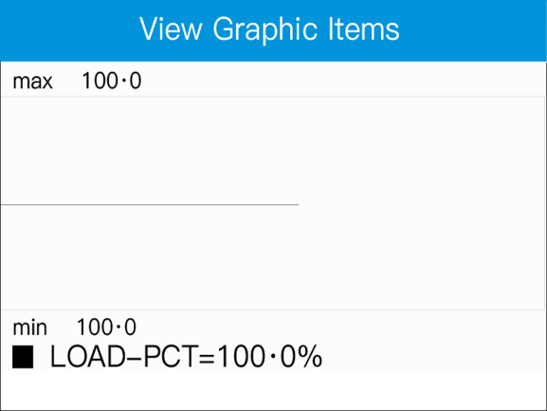
Figure 3-3-6 Graphic Items Display
NOTE: Merge Graph can be used to compare four related parameters in graphic mode.
Recording Data
A. Record All
1. Use UP/DOWN scroll button to select Record All from Live Data
2. menu and press the OK button.
3. The scan tool will start timing to record retrieved live data.
4. Press ESC to stop recording.
5. You may review the recorded data in Review function.

B. Record Select
1. Use UP/DOWN scroll button to select Record Select from Live Data menu and press the OK button.
2. Use the UP/DOWN scroll button to get the desired items, then press ESC, the scan tool will start timing to record selected live data.
3. Press ESC again to stop recording.
4. You may review the recorded data in Review function.

3.4 Freeze Frame Data
Freeze Frame Data: Operating conditions that are stored when a DTC is stored.
Freeze Frame Data allows the technician to view the vehicle's operating parameters at the moment a DTC is detected. For example, the parameters may include engine speed (RPM), engine coolant temperature (ECT), or vehicle speed sensor (VSS)etc.
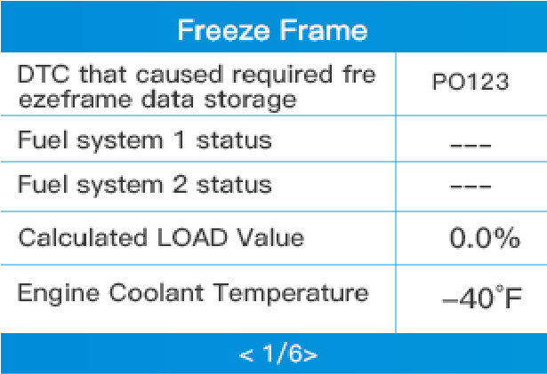
Figure 3-4-1 Freeze Frame Interface
1. Select Freeze Frame from Diagnostic Menu and press the OK button.
2. View data. If retrieved information covers more than one screen, use the DOWN scroll button as necessary, until all the data have been shown up.
3. Select Save to record freeze frame.

3.5 I/M Readiness Monitors
An important part of a vehicle's OBD II system is the Readiness Monitors, which are indicators used to find out if all of the emissions components have been evaluated by the OBD II system. They are running periodic tests on specific systems and components to ensure that they are performing within allowable limits.
Currently, there are eleven OBD II Readiness Monitors(or I/M Monitors) defined by the U.S. Environmental Protection Agency(EPA). Not all monitors are supported by all vehicles and the exact number of monitors in any vehicle depends on the motor vehicle manufacturer's emissions control strategy.
In order for the OBD monitor system to become ready, the vehicle should be driven under a variety of normal operating conditions. These operating conditions may include a mix of highway driving and stop and go, city type driving, and at least one overnight-off period. For specific information on getting your vehicles OBD monitor system ready, please consult your vehicle owner's manual.
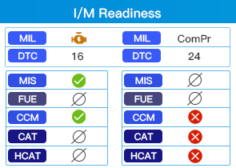
Figure 3-5 I/M Readiness Interface
I/M Readiness function is used to check the operations of the Emission System on OBD2 compliant vehicles. It is an excellent function to use prior to having a vehicle inspected for compliance to a state emissions program.
CAUTION - By clearing trouble codes you also clear the readiness status for the individual emission system readiness tests. In order to reset these monitors, the vehicle must be driven through a complete drive cycle with no trouble codes in memory. Times for reset vary depending on vehicle.
Some latest vehicle models may support two types of I/M Readiness tests:
1. Since DTCs Cleared - indicates status of the monitors since the DTCs are erased.
2. This Drive Cycle - indicates status of monitors since the beginning of the current drive cycle.
An I/M Readiness Status result of "NO" does not necessarily indicate that the vehicle being tested will fail the state I/M inspection. For some states, one or more such monitors may be allowed to be "Not Ready" to pass the emissions inspection.
-- Indicates that a particular monitor being checked has completed its diagnostic testing.
-- Indicates that a particular monitor being checked has not completed its diagnostic testing.
-- The monitor is not supported on that vehicle.
1. Press I/M Readiness button to enter.
2. Wait a few seconds while the scan tool validates the PID MAP.
3. If the vehicle supports both types of tests, then both types will be shown on the screen for selection.
4. Use the UP/DOWN scroll button, as necessary, to view the status of the MIL light ("ON" or "OFF") and the following monitors:
- For spark ignition engines:
- MIS - Misfire Monitor
- FUEL - Fuel System Monitor
- CCM - Comprehensive Component Monitor
- EGR - EGR System Monitor
- O2S - O2 Sensors Monitor
- CAT - Catalyst Monitor
- EVAP - Evaporative System Monitor
- HTR - O2 Sensor Heater Monitor
- AIR - Secondary Air Monitor
- HCAT - Heated Catalyst Monitor For compression ignition engines:
- MIS - Misfire Monitor
- FUEL - Fuel System Monitor
- CCM - Comprehensive Component Monitor
- EGR - EGR System Monitor
- HCCAT - NMHC Catalyst Monitor
- NCAT - NOx Aftertreatment Monitor
- BP -- Boost Pressure System Monitor
- EGS - Exhaust Gas Sensor Monitor
- PM - PM Filter Monitor

3.6 MIL Status
The MIL Status allows checking the status of MIL and run time/ distance with Check Engine Light on, run time/distance since DTC cleared.
1. Select MIL from Diagnostic Menu and press OK button.
2. Use the UP/DOWN scroll button to select the item you’d like to check
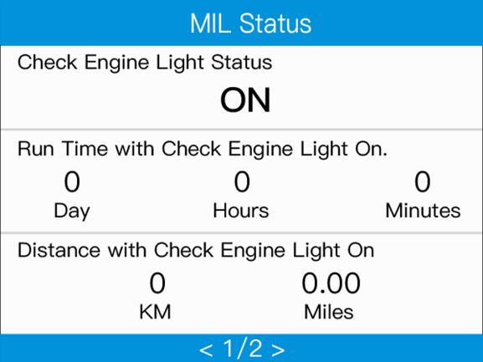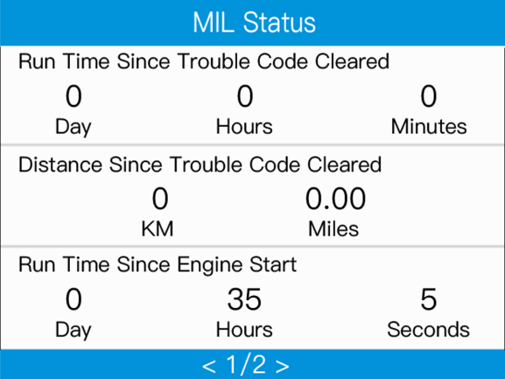
Figure 3-6-1 MIL Status Interface Figure 3-6-2 MIL Status Interface

3.7 Vehicle Information
The Vehicle Info. function enables retrieval of Vehicle Identification No. (VIN), Calibration ID Nos.(CINs), Calibration Veriﬁcation Nos.(CVNs) .
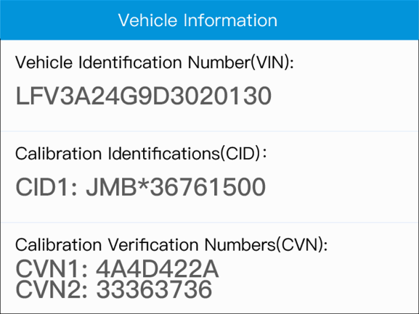
Figure 3-7 Vehicle Information Interface
1. Select Vehicle Info. from the Diagnostic Menu and press OK button.
2. View retrieved vehicle information on screen.

3.8 Mode 6
Mode 6 (On-Board Monitor Test) is useful after servicing or after erasing a vehicle's control module memory. The On-Board Monitor Test for non-CAN-equipped vehicles retrieves and displays test results for emission-related power train components and systems that are not continuously monitored. The On-Board Monitor Test for CAN-equipped vehicles retrieves and displays test results for emission-related power train components and systems that are and are not continuously monitored. Test and components IDs are determined by the vehicle manufacturer.
In this test, there are typically a minimum value, a maximum value, and a current value for each monitor. By comparing the current value with the minimum and maximum value, the scan tool will determine if it is OK.
1. From Mode 6 menu, use the UP/DOWN scroll button to select a test to view and press the OK button.
2. Wait a few seconds while the scan tool validates the PID MAP.
3. The scan tool will prompt you to select the vehicle make. (If you have selected the vehicle before, the Vehicle Manufacturer screen would not appear again)
4. After you select the vehicle manufacturer, the scan tool shows the On-Board Monitors tests for specific monitoring systems.
If the vehicle under test does not support the mode, an advisory message will be displayed on the screen.
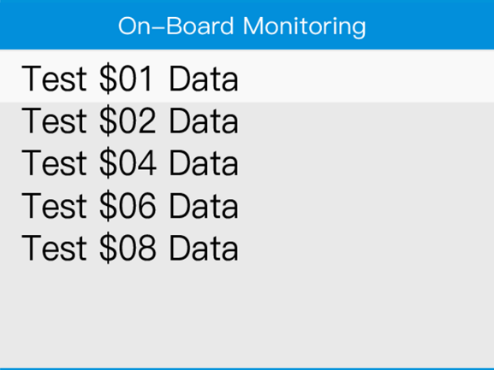 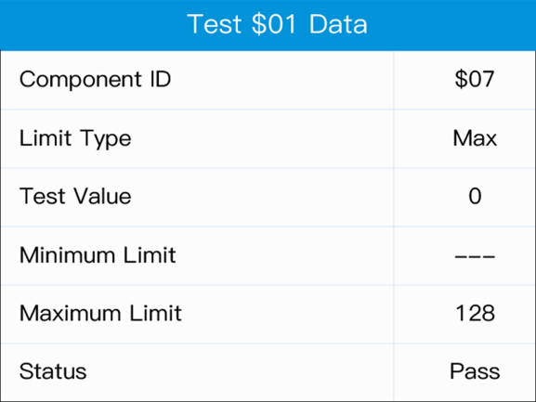Figure 3-8-1 On-Board Monitoring Interface Figure 3-8-2 Test $01 Data Example

3.9 Mode 8
Mode 8 (The Component Test) function allows initiating a leak test for the vehicle's EVAP system. The scan tool itself does not perform the leak test, but commands the vehicle's on-board computer to start the test. Different vehicle manufacturers might have different criteria and methods for stopping the test once it has been started. Before starting the Component Test, refer to the vehicle service manual for instructions to stop the test.
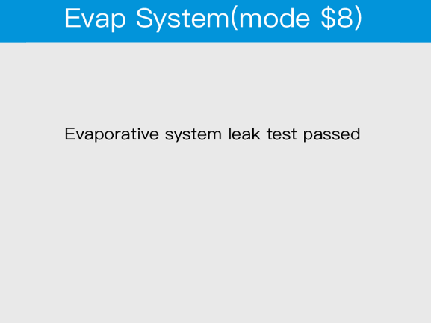
Figure 3-9 Mode 8 Display Interface
1. Select Mode 8 from Diagnostic Menu and press the OK button.
2. If the test has been initiated by the vehicle, a confirmation message will be displayed on the screen.
3. Some vehicles do not allow scan tools to control vehicle systems or components. If the vehicle under test does not support the EVAP Leak Test, an advisory message is displayed on the screen.

3.10 Smog Check
Smog Check: Check for whether the vehicle emission meets the standard, and display the various indications and statuses for owner vehicle.
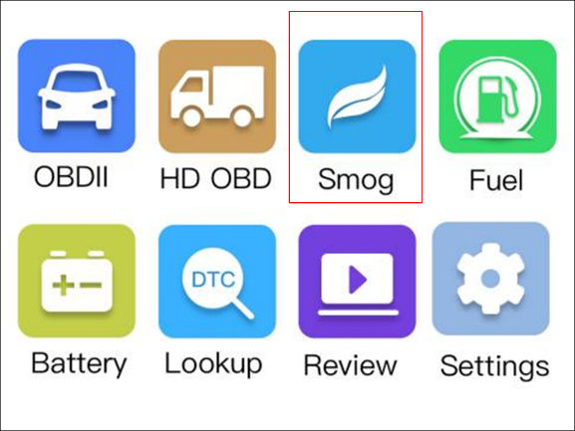 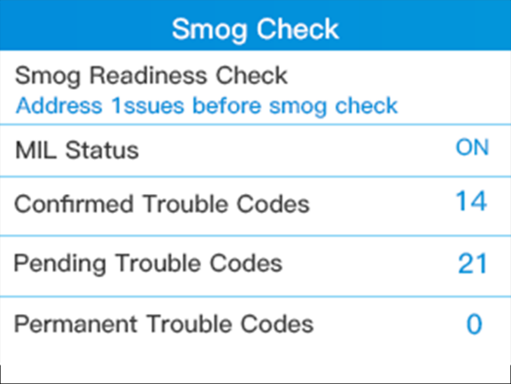Figure 3-10-1 Smog Check Selection Interface Figure 3-10-2 Function Display Interface

3.11 Fuel Analysis
Fuel Analysis: Analyze the instant, idle speed and average fuel consumptions in the cars.
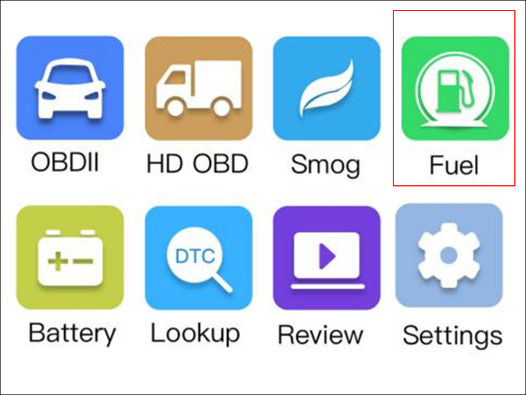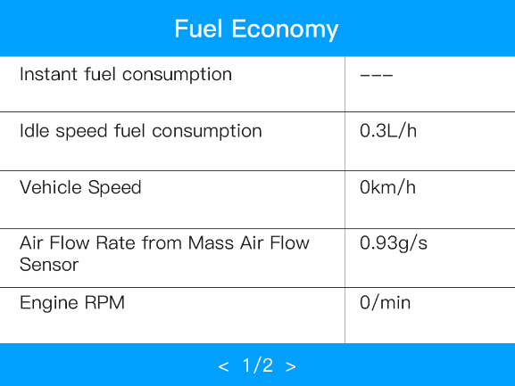
Figure 3-11-1 Fuel Analysis Selection Interface Figure 3-11-2 Function Display Interface

4. HD OBD Diagnosis

4.1 Read DTCs
There are three types of DTCs:
1. Stored DTCs - A DTC is stored when a fault condition has occurred that meets enough criteria to activate the MIL.
2. Pending DTCs - When a fault condition is identified during a Drive Cycle, but does not meet enough criteria to activate the MIL. If the fault condition occurs during two consecutive Drive Cycles, it will turn into a Stored DTC and the MIL will activate.
3. Permanent DTCs - A stored DTC that can only be cleared by the OBDII system, after repairs are made, and a set number of Driving Cycles have been completed.
Select SAE J1939 and press OK button.
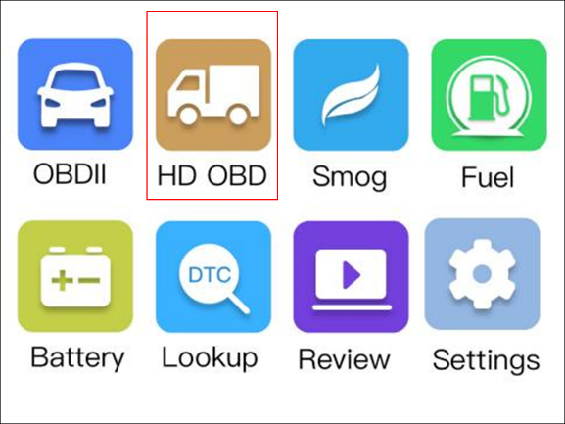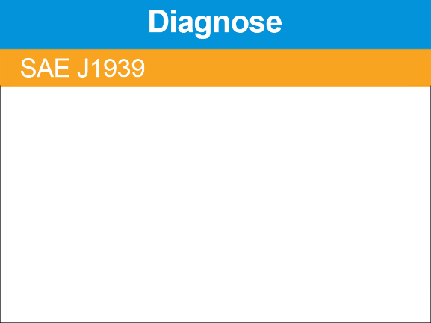
Figure 4-1-1 HD-OBD Selection Interface Figure 4-1-2 J1939 Selection Interface
1. Use the UP/DOWN scroll button to select Vehicle Information, Read Codes, Erase Codes or Data Stream from the Diagnostic menu and press the OK button.
2. Use UP/DOWN scroll button to select Read Codes from Diagnostic Menu and press OK button.
3. Use the UP/DOWN scroll button to select Stored DTC, Pending Codes, Permanent Codes or record DTC from the Read Codes menu and press the OK button.
If there is not any Diagnostic Trouble Code, the display indicates "The vehicle has no fault codes!" Wait a few seconds or press any key to exit.
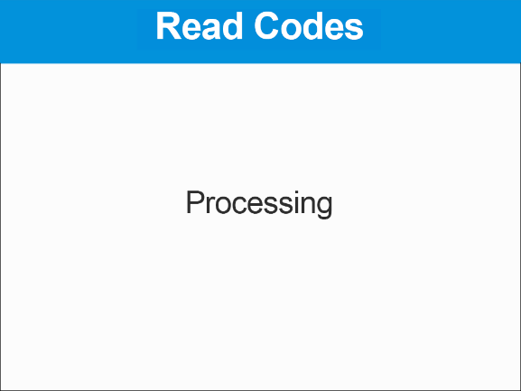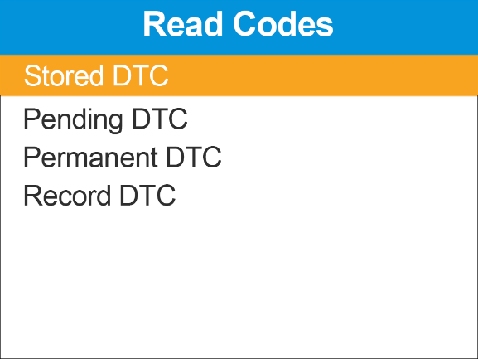
Figure 4-1-3 Detection protocol Interface Figure 4-1-4 J1939 Function Interface

4.2 Clear DTCs
NOTE: Erasing codes does not mean that trouble codes in ECU have been eliminated completely. As long as there is fault with the vehicle, the trouble codes keep on presenting.
This function is performed with key on engine off (ROEO). Do not start the engine.
The Clear DTCs function can erase Stored DTC and Pending DTC in ECUs’ memory, but cannot erase the Permanent DTC.
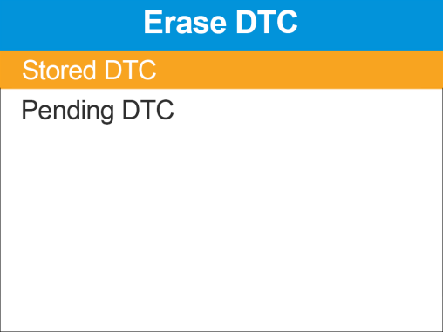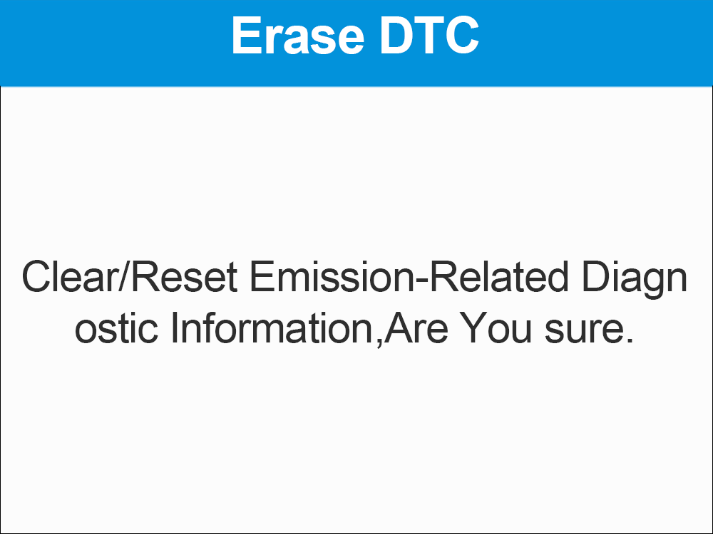
Figure 4-2-1 Erase DTC Selection Interface Figure 4-2-2 Clear DTC Confirm Interface
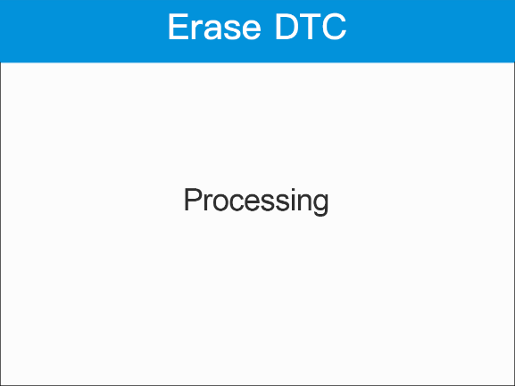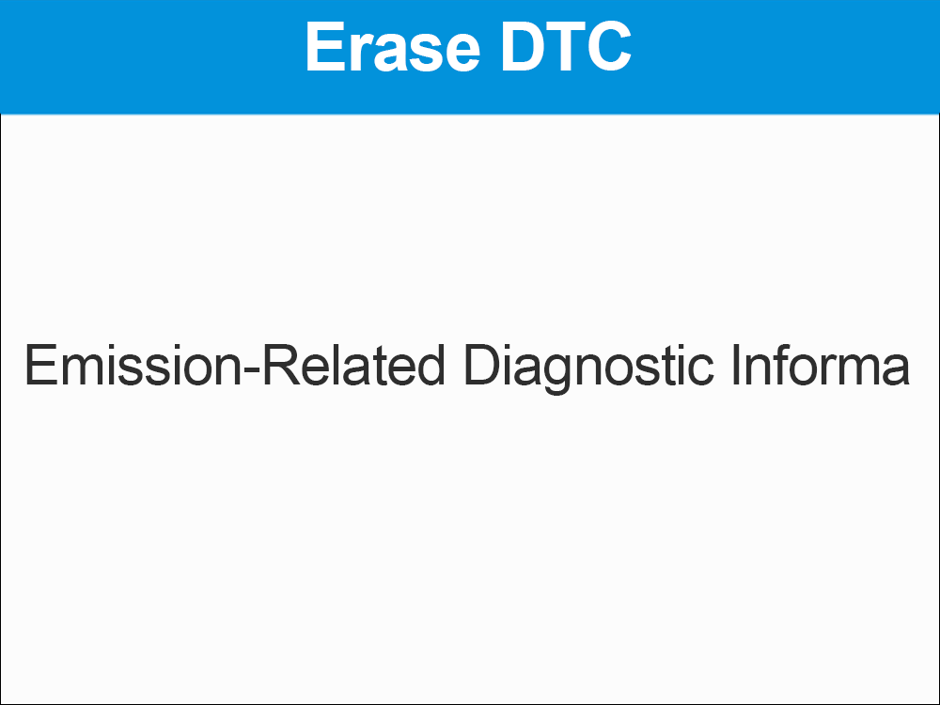
Figure 4-2-3 Erase DTC Progress Information Interface Figure 4-2-4 Clear DTC Finish Interface

4.3 Live Data
View All Items
1. To view complete set of data, use UP/DOWN scroll button to select View All Items from Live Data menu and press the OK button.
2. View live PIDs on the screen. Use the UP/DOWN or Left/Right scroll button for more PIDs if additional information is available on more than one page.
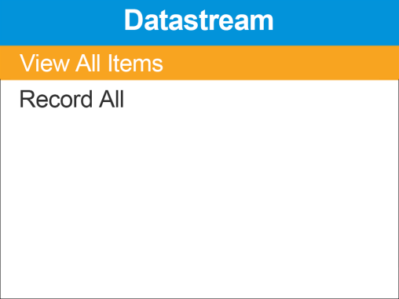
Figure 4-3 Data Stream Interface

4.4 Vehicle Information
The Vehicle Info. function enables retrieval of Vehicle Identification No. (VIN), Calibration ID Nos.(CINs), Calibration Veriﬁcation Nos.(CVNs) .
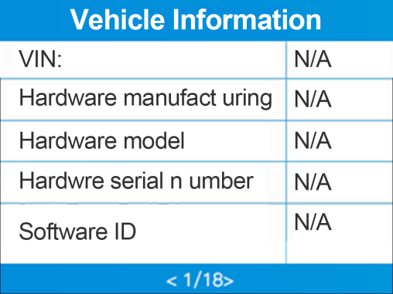
Figure 4-1 Vehicle Information Interface

5. Battery Test
The Battery Test function allows viewing the status and the voltage of the vehicle.
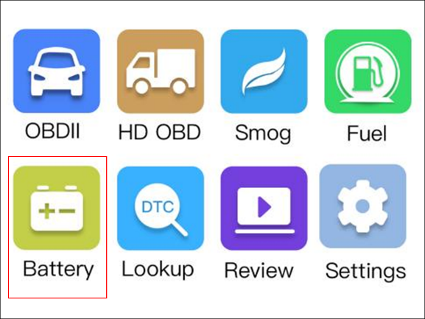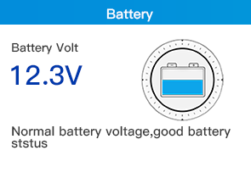
Figure 5-1 Battery Selection Interface Figure 5-2 Battery Test Interface
1. Select Battery from Diagnostic Menu and press OK button.
2. You can clearly see the status and the voltage of the vehicle.

6. Look up
The Look up function allows user to search definitions of DTC stored in built-in DTC library.
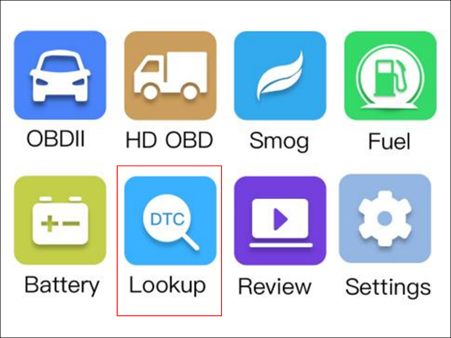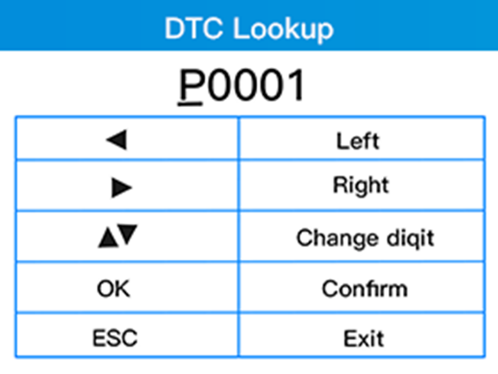
Figure 6 DTC Look up Interface
1. Use the UP/DOWN scroll button to select DTC Query from Diagnostic Menu and press OK button.
2. Wait for the scan tool to display the DTC Query screen.
3. Press UP/DOWN to change input and press LEFT/RIGHT to select position. Then press OK button to conﬁrm and the scan tool will display this code's definition on screen.
If definition could not be found (SAE or Manufacturer Specific), the scan tool displays "The fault code is not found in the database" .
4.Press ESC button to return to previous menu.

7. Review
The Review function allows viewing data from last test recorded by the scan tool.
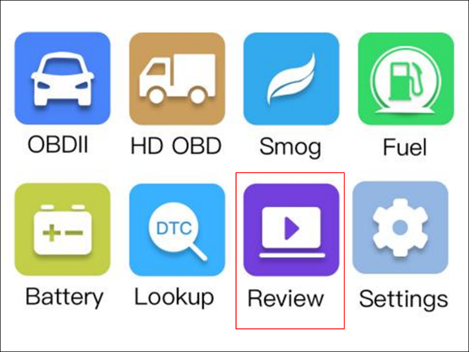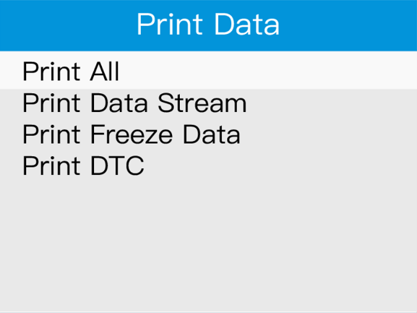
Figure 7-1 Print Data Selection Interface Figure 7-2 Print Data Function Interface

7.1 Review DTC
1. Select Review from Main Screen, and press the OK button.
2. Use the UP/DOWN scroll button to select the item you'd like to review. Then press OK button to continue.
3. Review selected data on screen. If no data from previously tested vehicle is recorded, a message "No data available!" shows on the screen.

7.2 Printing Data
The Print Data function allows printing out diagnostic data recorded by the scan tool by connecting the scan tool to a PC or laptop with the USB cable supplied. To print out retrieved data, you need the following tools:
1. Download the applications in our website: www.humzor.com or our distributors’ site.
2. Connect the scanner to computer with the USB cable supplied.
3. Run Printer software on computer.
4. Select Print function in Main Screen of the scan tool. In Scan screen, select the files you want to print. Wait for the reviewing window to display, and then select Print function. The selected file will be uploaded to your computer.
5. The selected data will display on the text box of Printer. By selecting the function keys on the right , you are also allowed to edit, copy, and delete the data in the Printer window.
NOTE: The scan tool can only print text data even though the data is saved in graphic mode.

8. Setting
The System Setup functions allow you to adjust default settings and view information about the scan tool.
1. Language: Selects the desired language, support English, French, German, Spanish, Russian, Chinese and Italian.
2. Help: Information about the unit and Vehicle diagnostics.
3. Unit of measure: Sets the unit of measure to English or Metric.
4. Beep: Turns on/off beep.
5. Device Self-Test: Checks if the keyboard, LCD display or the screen is working properly.
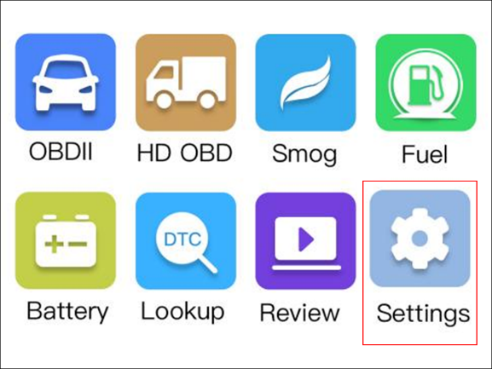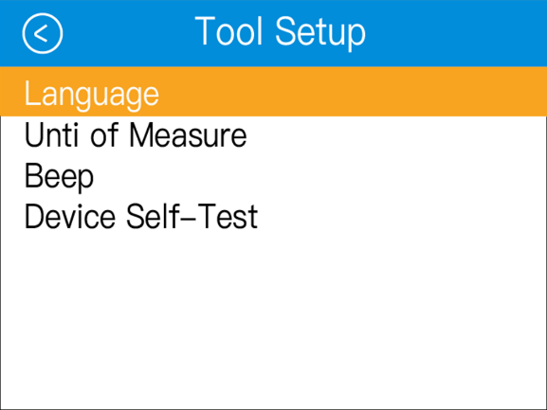
Figure 8-0-1 Tool Setup Selection Interface Figure 8-0-2 Tool Setup Function Interface
To enter the Setup menu From the Main Screen: Use LEFT/RIGHT scroll button to select Setting, and press the OK button. Following the instructions to do adjustments and settings could make your diagnosis more conveniently and easily.

8.1 Language Setup
English is the default language.
Use the UP/DOWN scroll button to select the desired language and press the OK button to save your selection and return to previous screen.
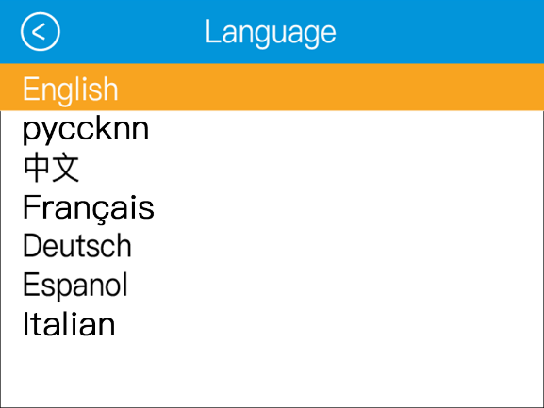
Figure 8-1 Languages Interface

8.2 Help Function
Show users information about the tool, OBD and DataStream.
Use the UP/DOWN scroll button to select the desired information and press the OK to view the information.
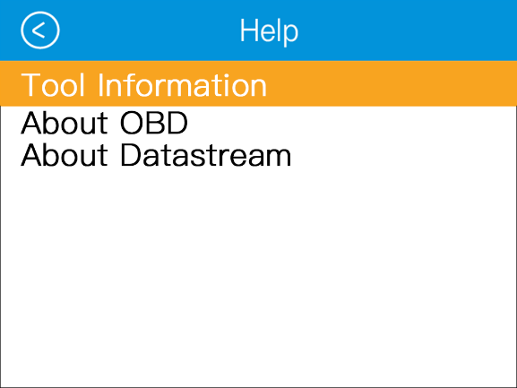
Figure 8-2 Help Interface

8.3 Unit of Measure
Metric is the default measurement unit.
From Unit of Measure screen, use the OK button to select the desired unit of measurement.
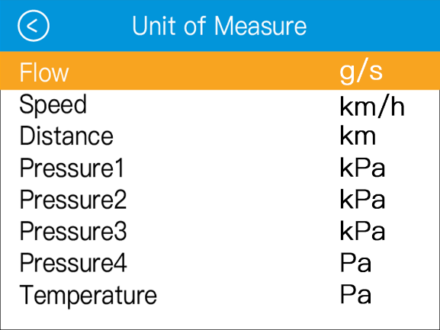
Figure 8-3 Unit of Measure Interface

8.4 Beep Setting
The default setting is Beep On.
From Beep Set menu, use the OK button to select ON or OFF to turn on/off the beep.
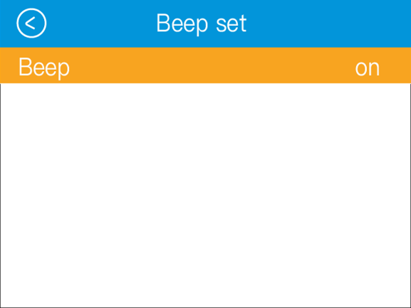
Figure 8-4 Beep Set Interface

8.5 Device Self-Test
Check if the Screen, Keyboard and LED is working properly.
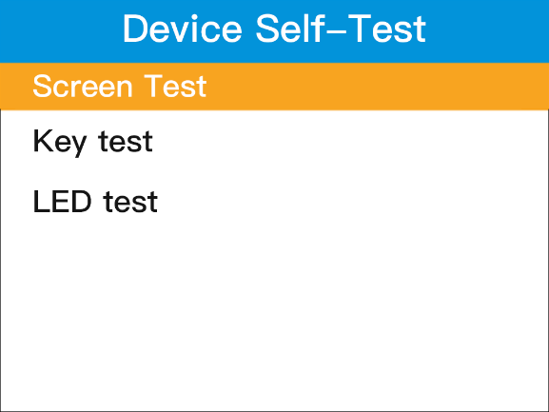
Figure 8-5 Device Self-Test Interface

8.5.1 Screen Test
The Screen test function checks if the screen display is working properly.
Look for errors after the screen color changes.

8.5.2 LCD Test
The LCD Test function checks if the LCD display is working normally.
- Wait a minute then look for missing spots in the red, green, yellow LCD display.
- When completed, press the ESC button to exit.

8.5.3 Key Test
The Key Test function checks if the keyboard is working properly.
1. Press any key to start test. When you press a key, the name of corresponding key will show on the screen. Otherwise, the key is not functioning properly.
2. Double press ESC to return to previous menu.
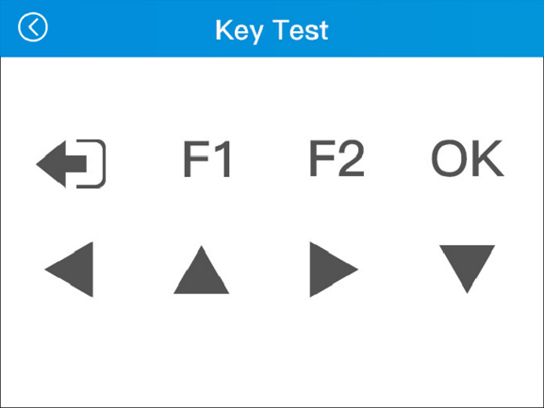
Figure 8-5 Key Test Interface

8.6 Vehicle Coverage
The Scan Tool is specially designed to work with all OBD II compliant vehicles, including those equipped with next-generation protocol- Control Area Network (CAN). It is required by EPA that all 1996 and newer vehicles (cars, light-duty and heavy-duty trucks) sold in the United States must be OBD II compliant and this includes all Domestic.
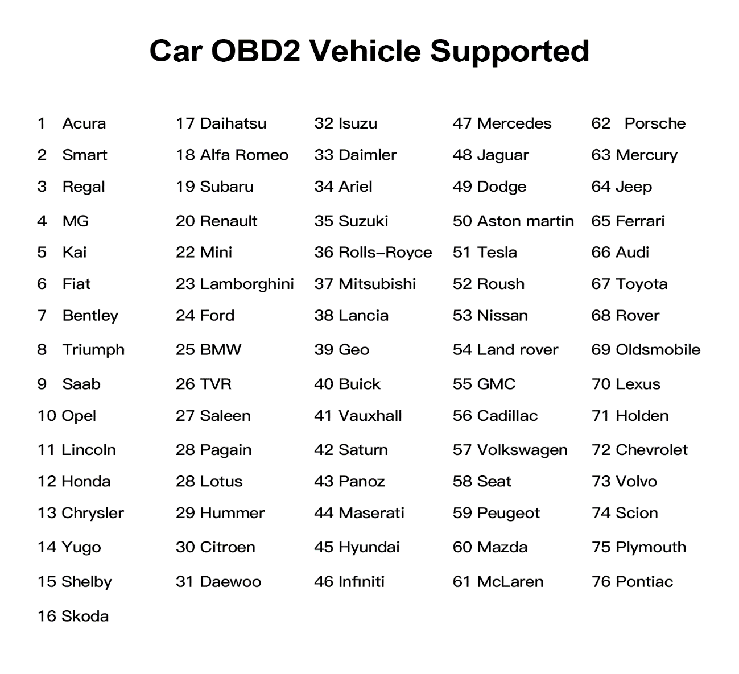
Figure 8-6-1 Car Code Coverage
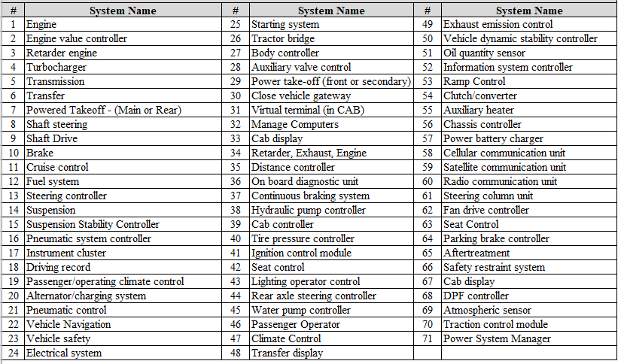
Figure 8-6-2 Truck Code Coverage

8.7 Protocol Coverage
Allows different systems and sensors in a vehicle to communicate. There are currently five Protocols: SAE_J1850(PWM, VPW), ISO_9141-2, ISO_14230-4(KWP, KWP-5BPS), ISO_15765-4(CAN, CAN-B, CAN-C, CAN-D).
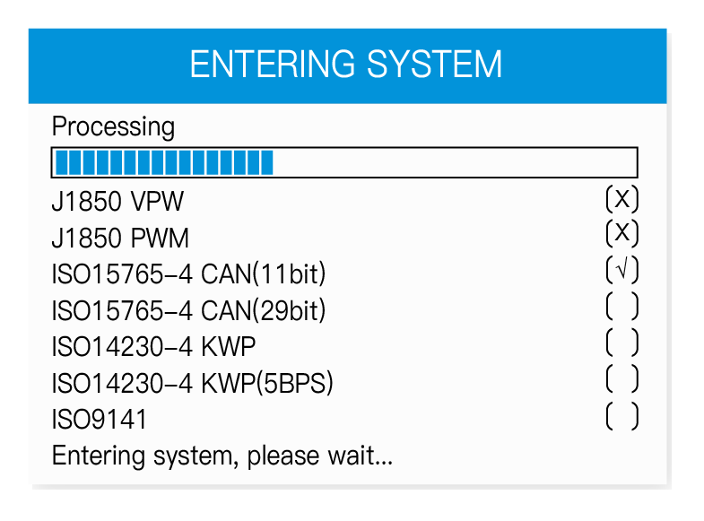
Figure 8-7 Enter Interface
PID-Parameter Identiﬁcation Data: Data returned by the vehicle's Control Modules to the Scan Tool.

8.8 Test Mode Coverage
Here is a basic introduction to the OBD II communication protocol.
Note: Not all Modes are supported by all vehicles.
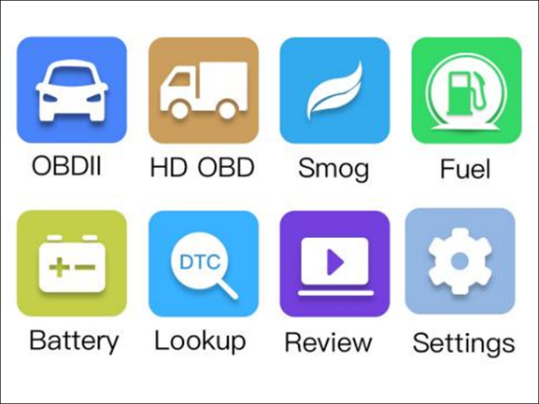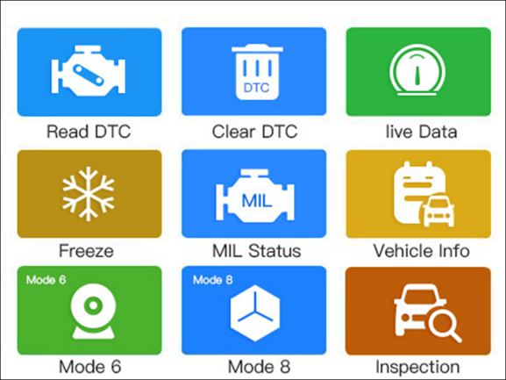
Figure 8-11-1 Main interface Figure 8-11-2 Functional interface
Mode $01-Identiﬁes the Power-train information and shows current data available to the scan tool.
Mode $02-Request Powertrain Freeze Frame Data. Mode $03-Request Emission-related stored DTCs.
Mode $04-Clear/reset Emission-related diagnostic information.
Mode $05-Request Oxygen Sensor Monitoring Test Results(2007 and older vehicles only)
Mode $06-Non-continuously Monitored System test results. Mode $07-Request for DTCs (pending) from Continuously Monitored Systems after a single driving cycle has been performed to determine if repair has fixed a problem.
Mode $08-Request control of on-Board system, test or component.
Mode $09-Request vehicle information.
Mode $0A-Request Emission-related permanent DTCs.
Mode $0B-Malfunction Indicator Lamp. The vehicle's "Check Engine" warning light that activates when a DTC is stored.
Mode $0C-Battery test. Viewing the status and the voltage of the vehicle.

8.9 Product Trouble shooting
Table 8-12 Product Trouble Example
Problem | Possible Cause | Likely Solutions
Scan Tool doesn't power up | - OBDII Cable connector not connected securely.  - Vehicle’s DLC pins are bent or broken.  - Vehicle’s battery is bad. | 1. Verify that the Scan Tool’s OBDII Cable  2. Check if the DLC pins are bent or broken.If bent or broken,have a certified technician repair the DLC.  3. Make sure vehicle's battery it providing at least 8V.
Vehicle Linking Error | 1.Vehicle is not OBD compliant.  - Ignition is off.  3. Bad connection | 1.Verify that the vehicle is OBDII compliant.  2.Verify that the ignition is ON.  3.Reset the tool by turning the ignition off,waiting 10 seconds,then turning the ignition back on.
Scan Tool Freezes | Scan Tool or vehicle's computer system not responding. | Reset the Scan Tool by turning the ignition off, waiting 10 seconds,then turning the ignition back on.

9. Update and Warranty

9.1 Software Update
This function allows you to update the scan tool software through a computer.
HUMZOR Technology frequently releases software updates that you can download. The Update feature makes it very easy to determine and get exactly what you need.
- Download the applications in our website: www.humzor.net or our distributors' site.
- Make sure that your computer is connected to the Internet.
- Connect the scanner to computer with the USB cable supplied.
- Run the update option in PC Suit software. Wait for the log in window to pop up.
- In the Update window, select the items you want to install.

9.2 Limited Three Year Warranty
HUMZOR Technology warrants to its customers that this product will be free from all defects in materials and workmanship for a period of one (1) year from the date of the original purchase, subject to the following terms and conditions:
- The sole responsibility of HUMZOR Technology under the Warranty is limited to either the repair or, at the option of HUMZOR Technology, replacement of the scan tool at no charge with Proof of Purchase. The sales receipt may be used for this purpose.
- This warranty does not apply to damages caused by improper use, accident, flood, lightning, or if the product was altered or repaired by anyone other than the Manufacturer's Service Center.
- HUMZOR Technology shall not be liable for any incidental or consequential damages arising from the use, misuse, or mounting of the scan tool. Some states do not allow limitations on how long an implied warranty lasts, so the above limitations may not apply to you.
- All information in this manual is based on the latest information available at the time of publication and no warranty can be made for its accuracy or completeness. HUMZOR Technology reserves the right to make changes at any time without notice.

9.3 Service Procedures
If you have any questions, please contact your local store, distributor or visit our website at www.humzor.net.
If it becomes necessary to return the scan tool for repair, contact your local distributor for more information.

